

**Universidad Autónoma de Guadalajara**

Biomedical Engineering

Peripherals and Interfaces

Jesús Arnoldo Zerecero Nuñez, 2885993

Edwin Francisco Zamora Oros, 2874382

*“Final project: Mynewt installation manual”*

19/11/18

**Virtual Machine installation:**

1. Download Ubuntu image for Virtual machine from <https://www.ubuntu.com/download/desktop>
2. Download and install VMware virtual machine to setup Ubuntu workspace from <https://www.vmware.com/mx/products/workstation-player/workstation-player-evaluation.html>
   1. Locate the downloaded image and load it into the VM Wizard

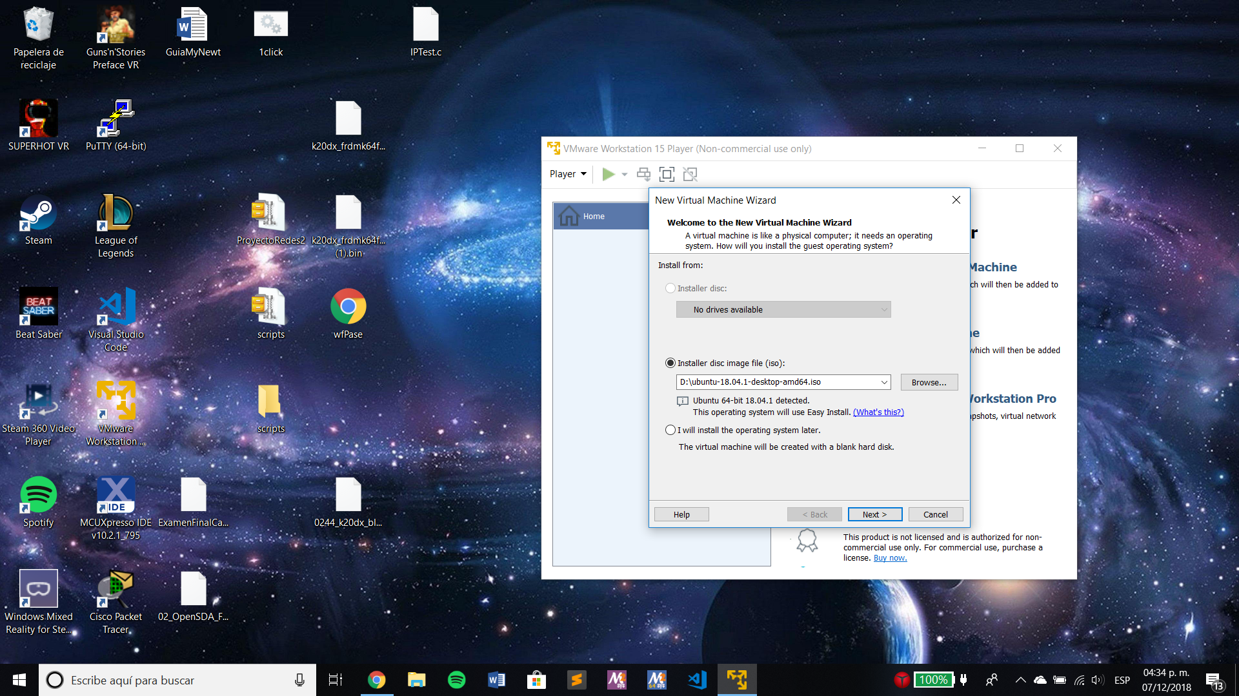

Ilustration 1: Virtual Machine Wizard

* 1. Introduce your Linux user credentials

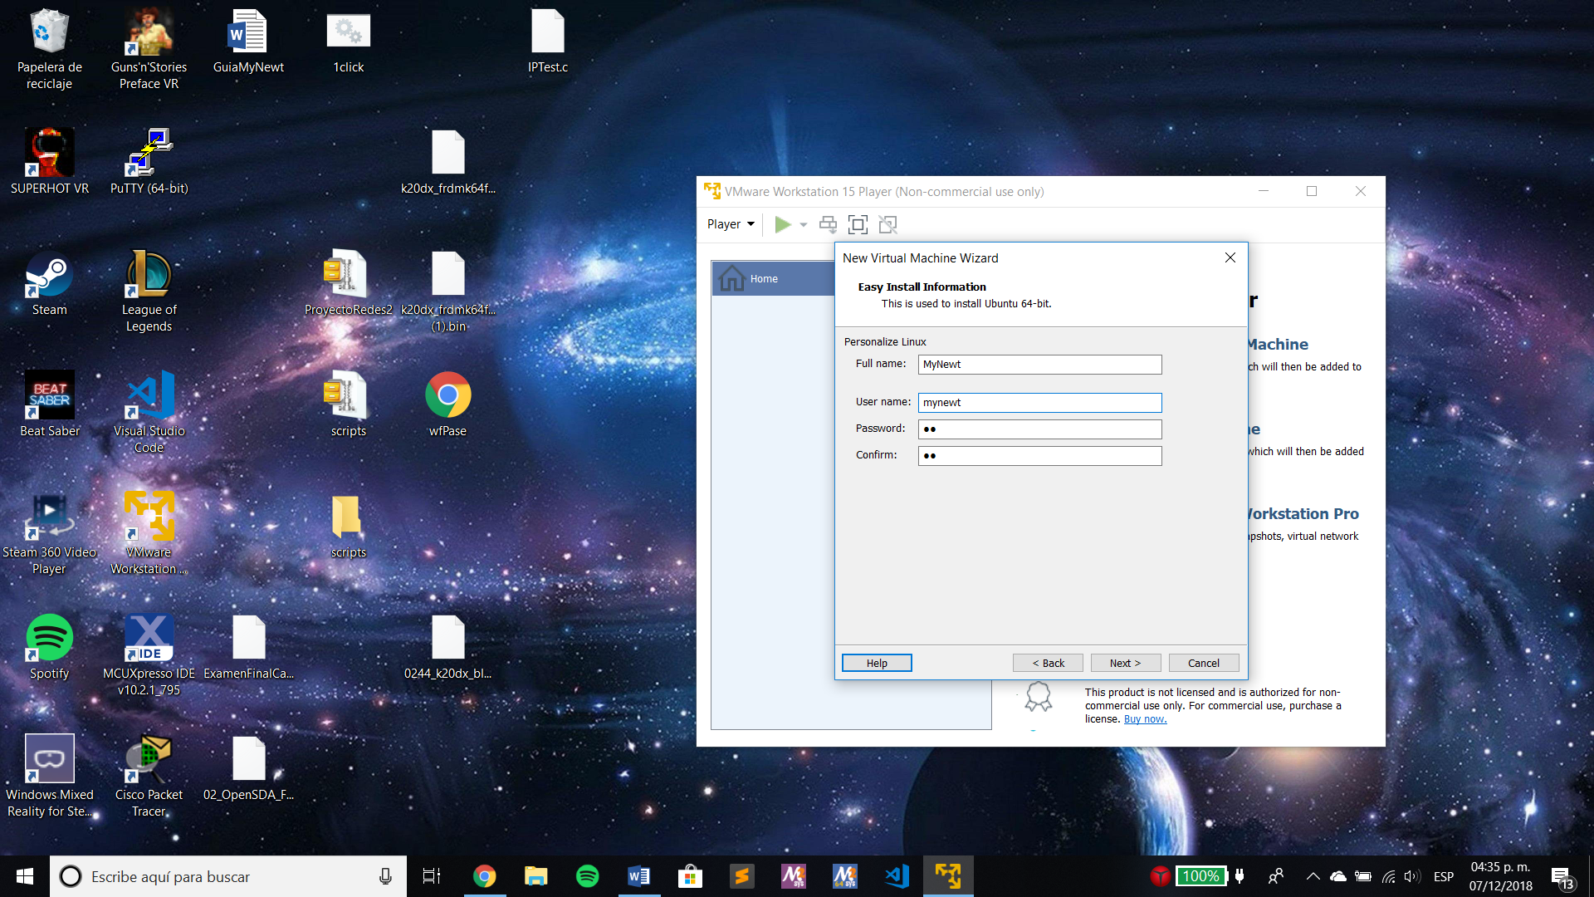

Ilustration 2 Virtual Machine Wizard Credentials

* 1. Name your virtual machine and assign it a directory

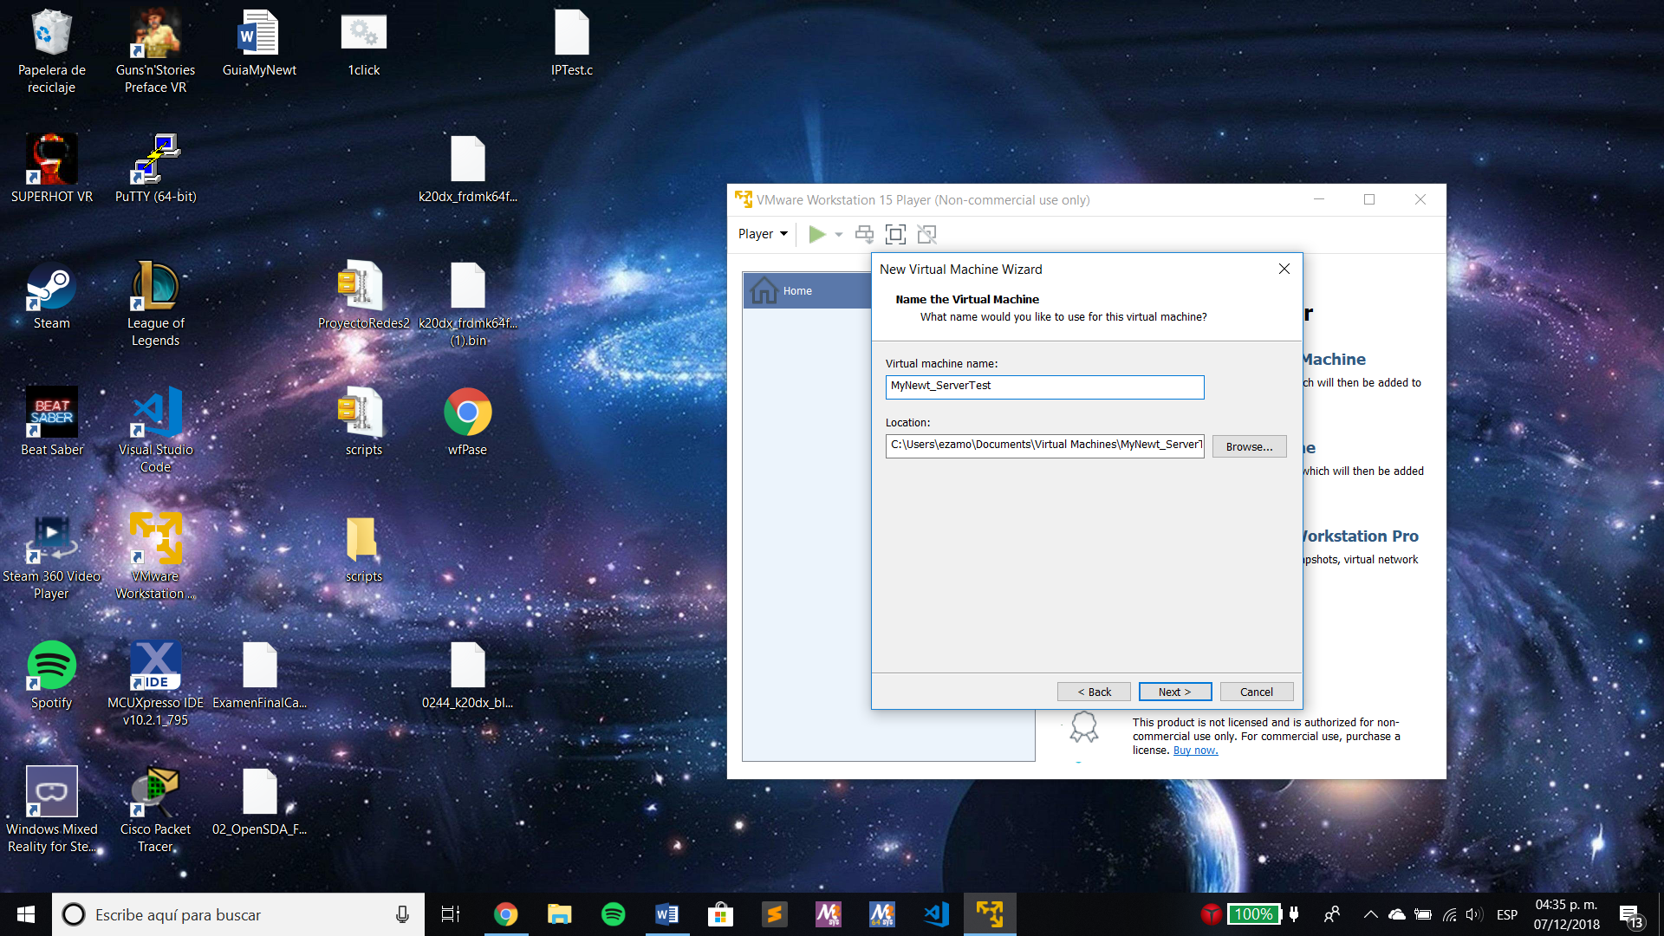

Ilustration 3 Naming the virtual machine

* 1. Assign as much disk space as desired. You can decide to store the virtual disk in a single file or split in into multiple files.

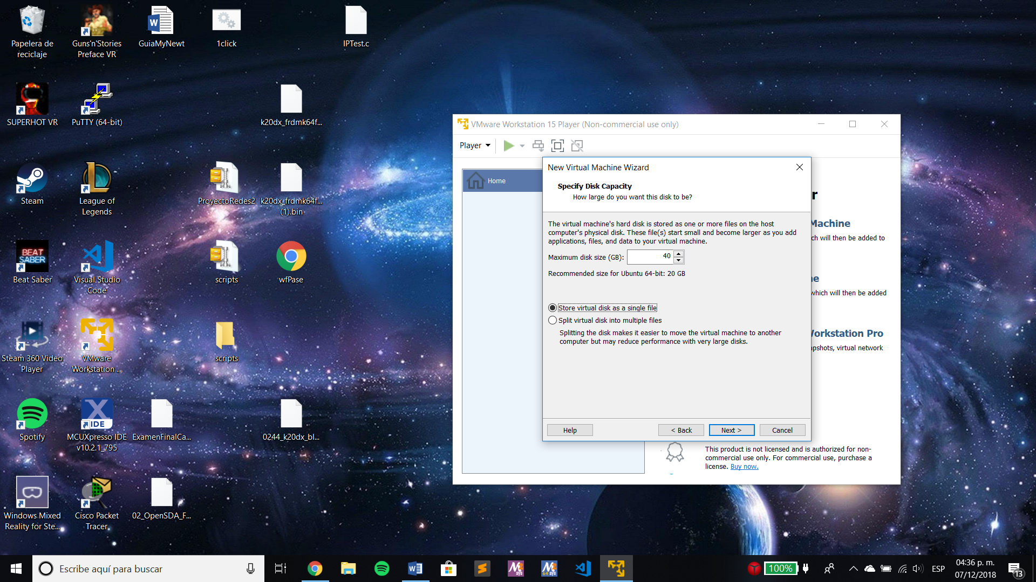

Ilustration 4 VM Wizard disk capacity specification

* 1. Check the assigned settings for your new virtual machine:

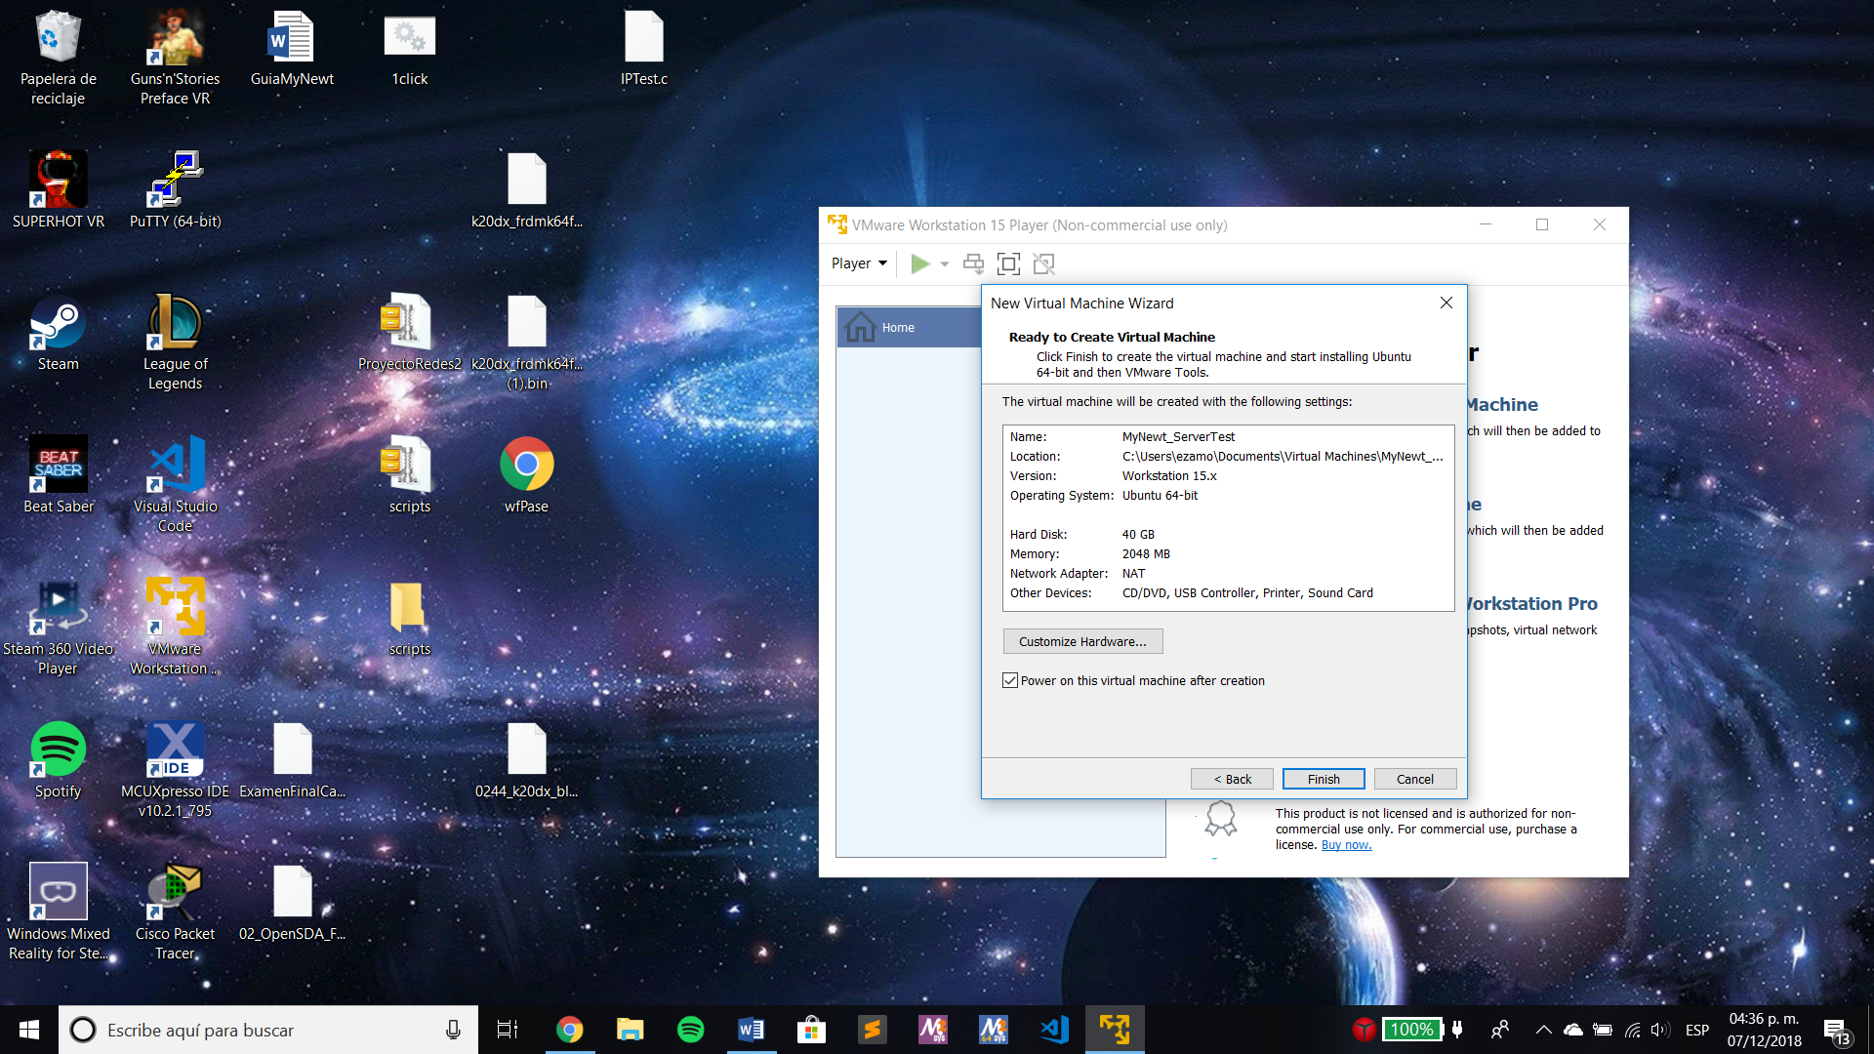

Ilustration 5 VM Wizard settings

* 1. Wait for the installation to finish and install the software updates (a message to do so will be shown automatically after the installation ends)

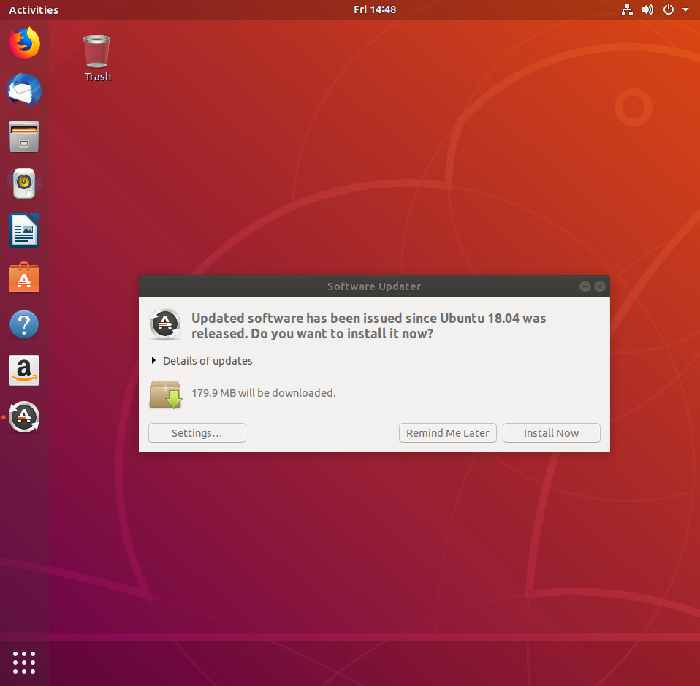

Ilustration 6 Software updates installation

* 1. Restart the virtual machine.

1. All ready to start Mynewt installation! Use Ctrl+Alt+t to open a terminal.

**Mynewt source and packages installation in Ubuntu 18.04.1:**

1. Install the apt-transport-https package to use HTTPS to retrieve packages. In case a password is required, use the same as the one used to login to Linux.

$ sudo apt-get update

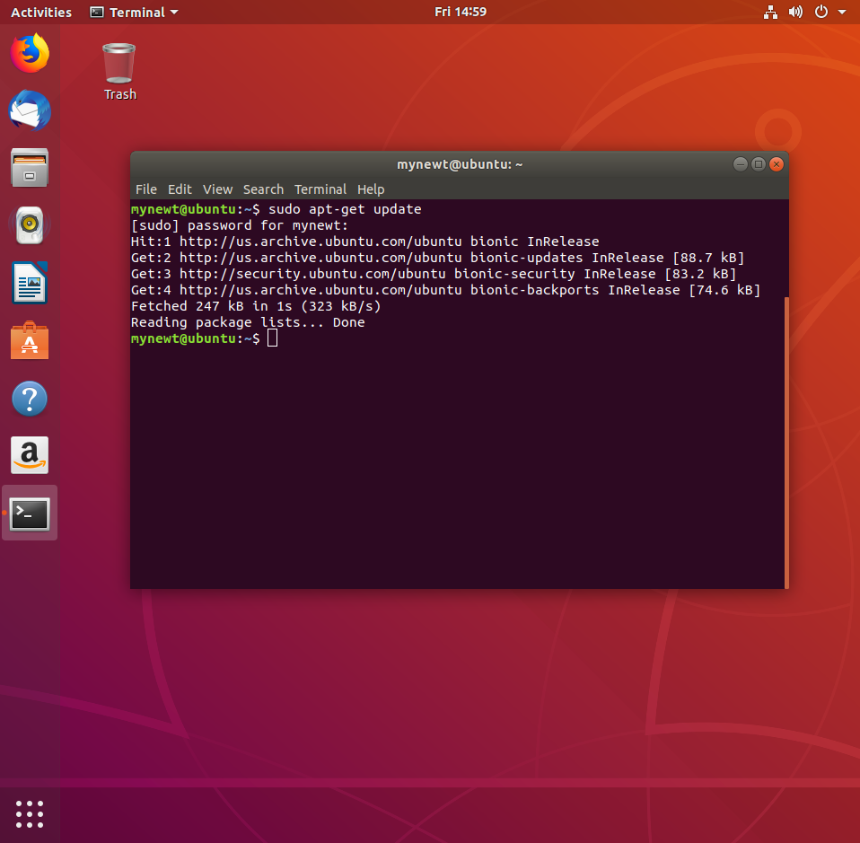

Ilustration 7 Update done succesfully

$ sudo apt-get install apt-transport-https

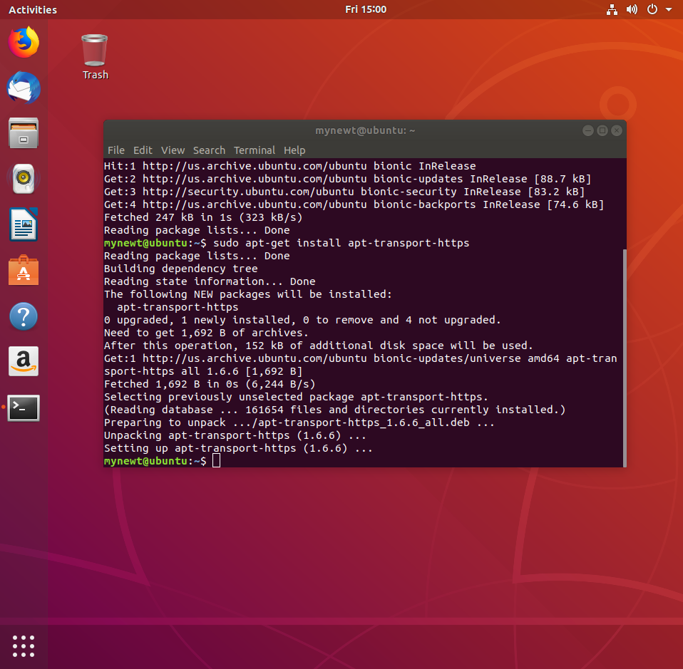

Ilustration 8 Installing packages for transport https

1. Download the public key for the runtimeco apt repo

$ wget -qO - https://raw.githubusercontent.com/runtimeco/debian-mynewt/master/mynewt.gpg.key | sudo apt-key add –

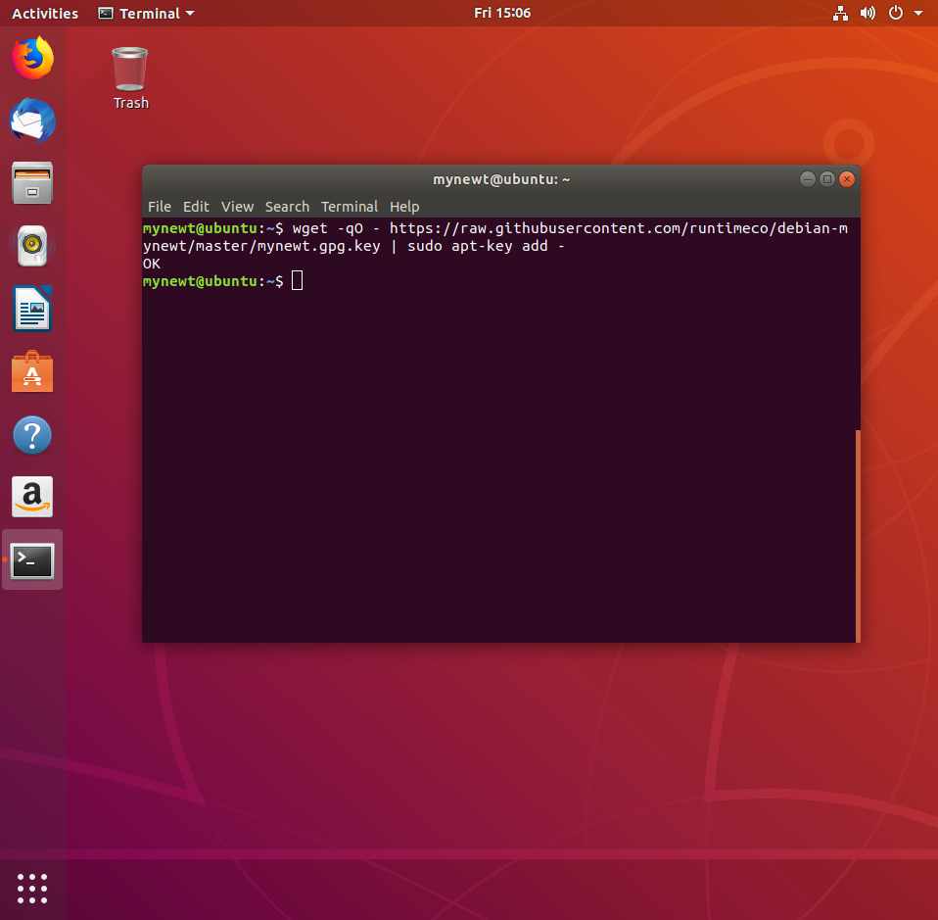

Ilustration 9 Runtimeco key downloading

1. Add the repository for the binary and source packages to the mynewt.list apt source list file

$ sudo -s

root$ cat > /etc/apt/sources.list.d/mynewt.list <<EOF deb https://raw.githubusercontent.com/runtimeco/debian-mynewt/master latest main EOF

root$ exit

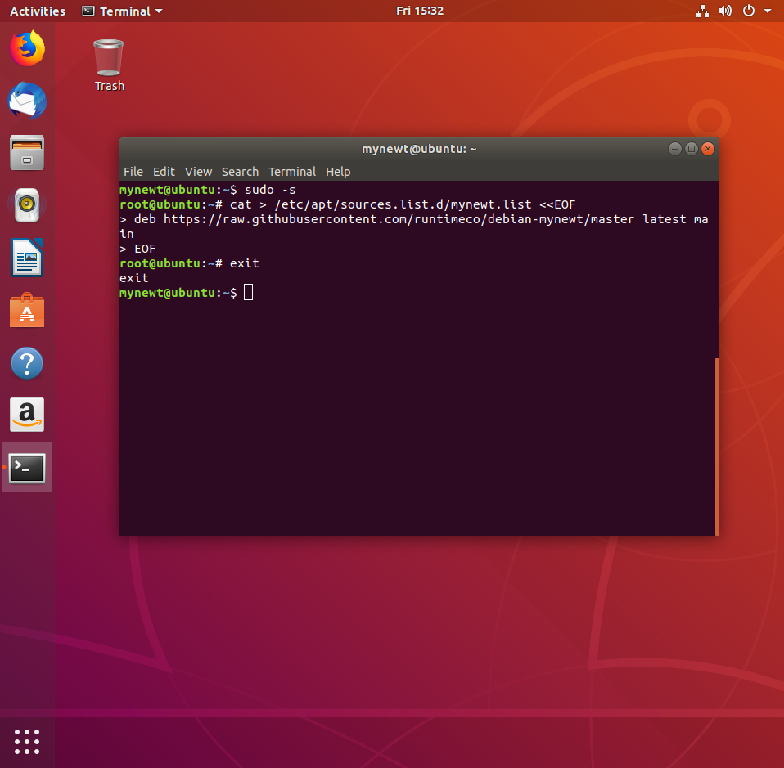

Ilustration 10 Root source packages downloading

1. Verify the content of the source list file

$ more /etc/apt/sources.list.d/mynewt.list

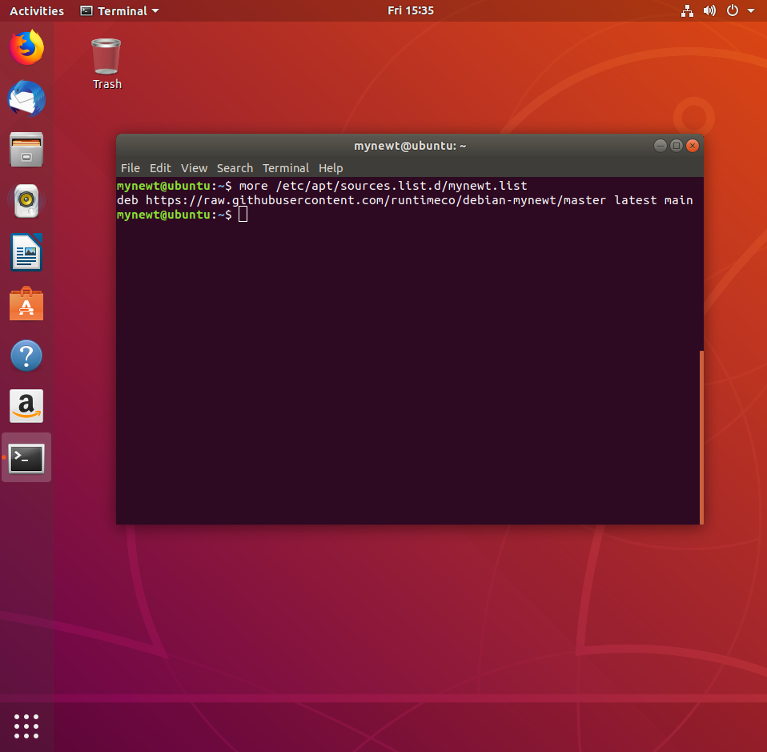

Ilustration 11 Source list content verification

1. Download the latest version of newt

$ sudo apt-get install newt

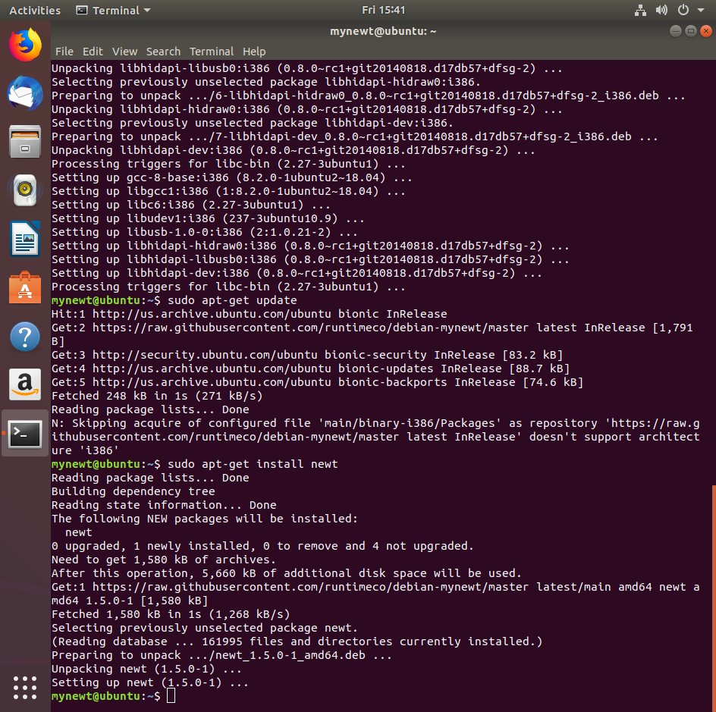

Ilustration 12 Newt installation

* + Instead, this method may be used:
    1. Download the latest version of Go

$ sudo apt install golang-go

* + 1. Download and unpack the newt source

$ wget -P /tmp <https://github.com/apache/mynewt-newt/archive/mynewt_1_1_0_tag.tar.gz>

$ tar -xzf /tmp/mynewt_1_1_0_tag.tar.gz

* + 1. Run the build.sh to build the newt tool

$ cd mynewt-newt-mynewt_1_1_0_tag

$ ./build.sh

$ rm /tmp/mynewt_1_1_0_tag.tar.gz

* + 1. Move the binary to a directory in your PATH (ex, /usr/bin)

$ mv newt/newt /usr/bin

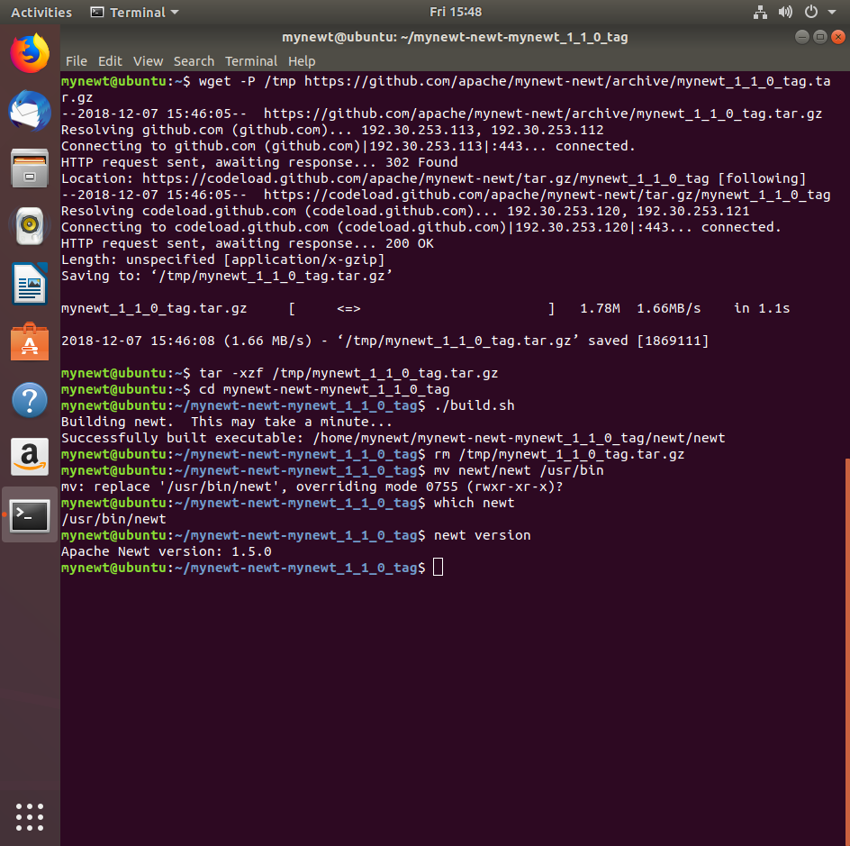

Ilustration 13 Alternative Newt installation

1. Check the Installed Version of Newt

$ which newt

$ newt version

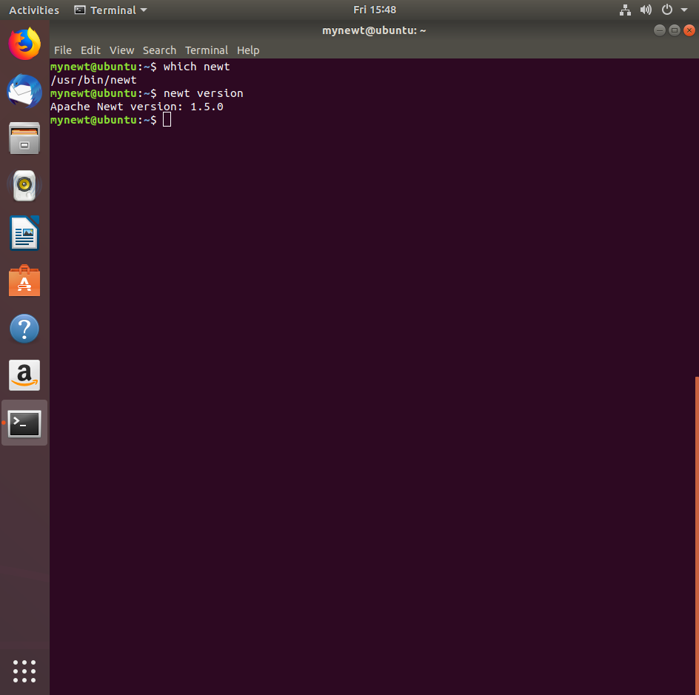

Ilustration 14 Newt version verification

1. Install gcc/libc, gdb, Git, Python2.7, Pip and pyOCD

$ sudo apt-get install gcc-multilib libc6-i386

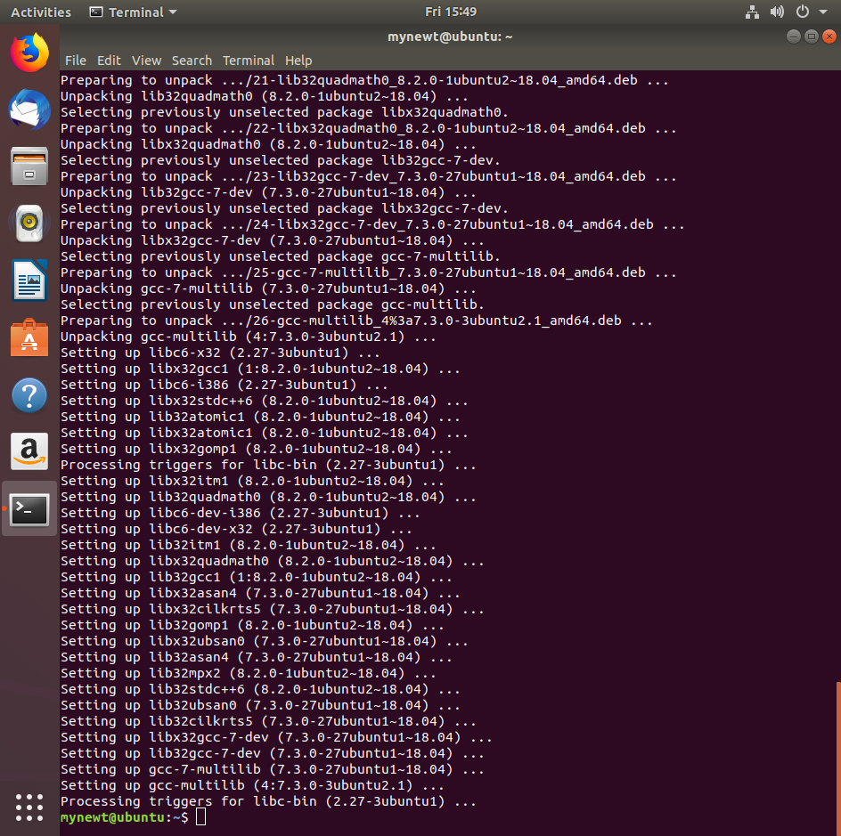

Ilustration 15 Gcc-multilib installation

$ sudo apt-get install gdb

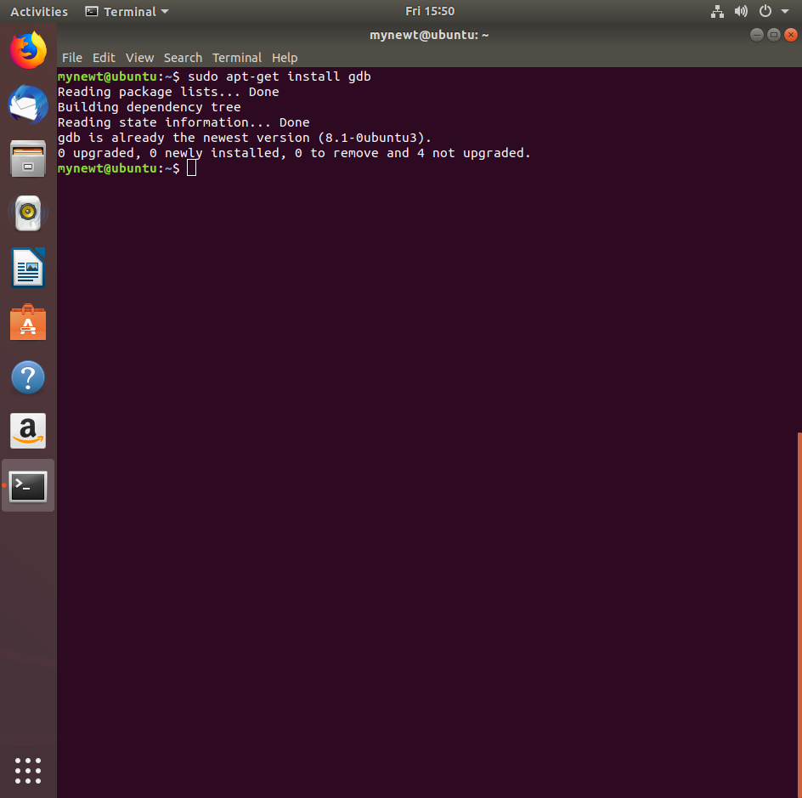

Ilustration 16 GDB installation

$ sudo apt install git

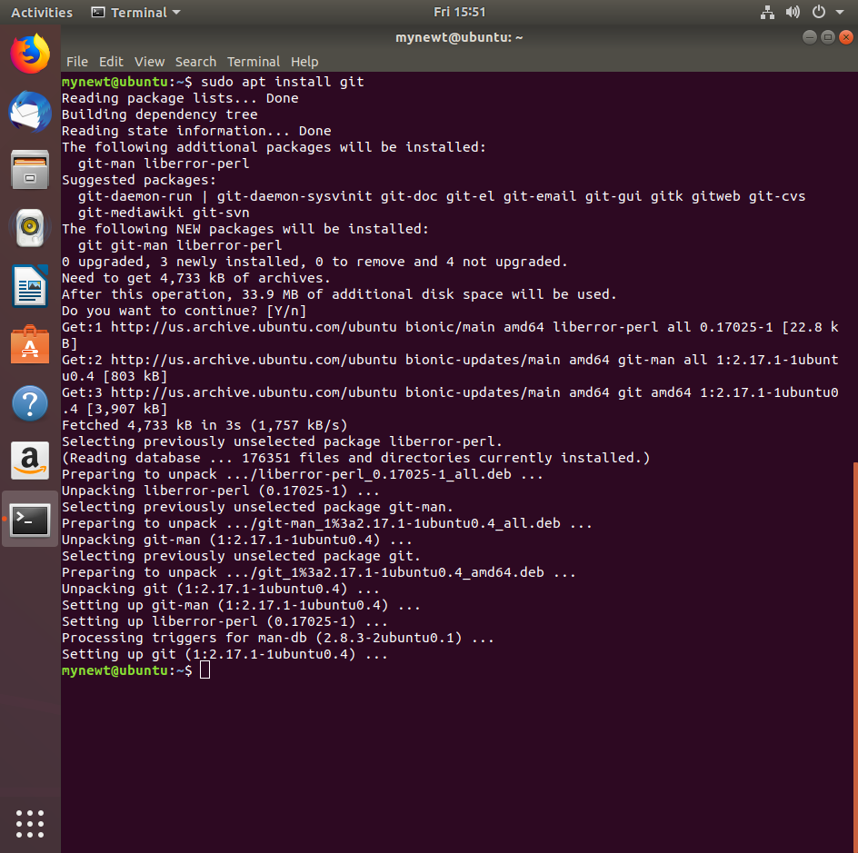

Ilustration 17 GIT installation

$ sudo apt install python2.7

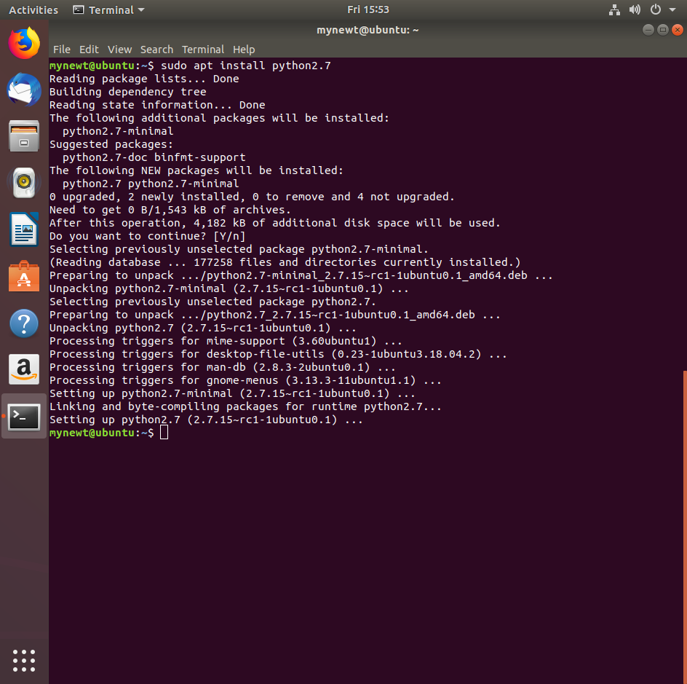

Ilustration 18 Python2.7 installation

$ sudo apt install python-setuptools

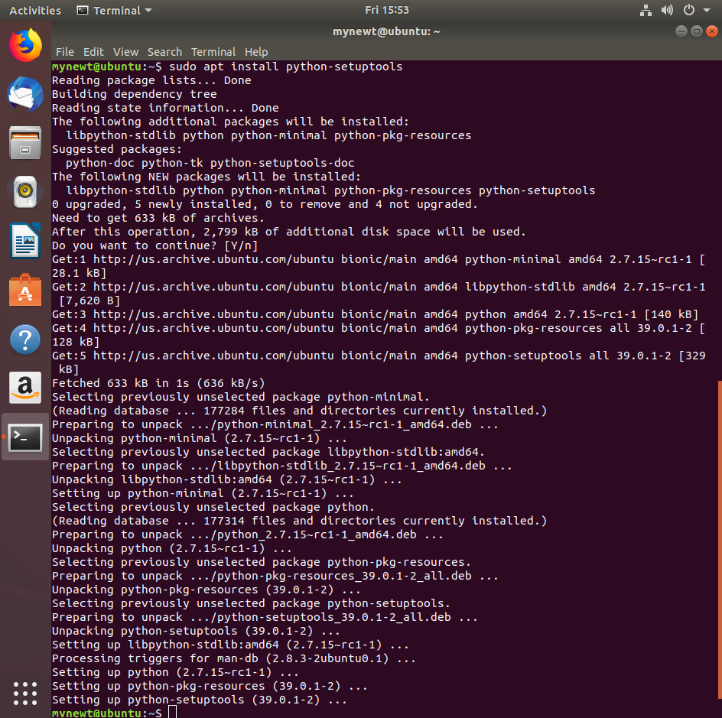

Ilustration 19 Python-setuptools installation

$ sudo apt install python-pip

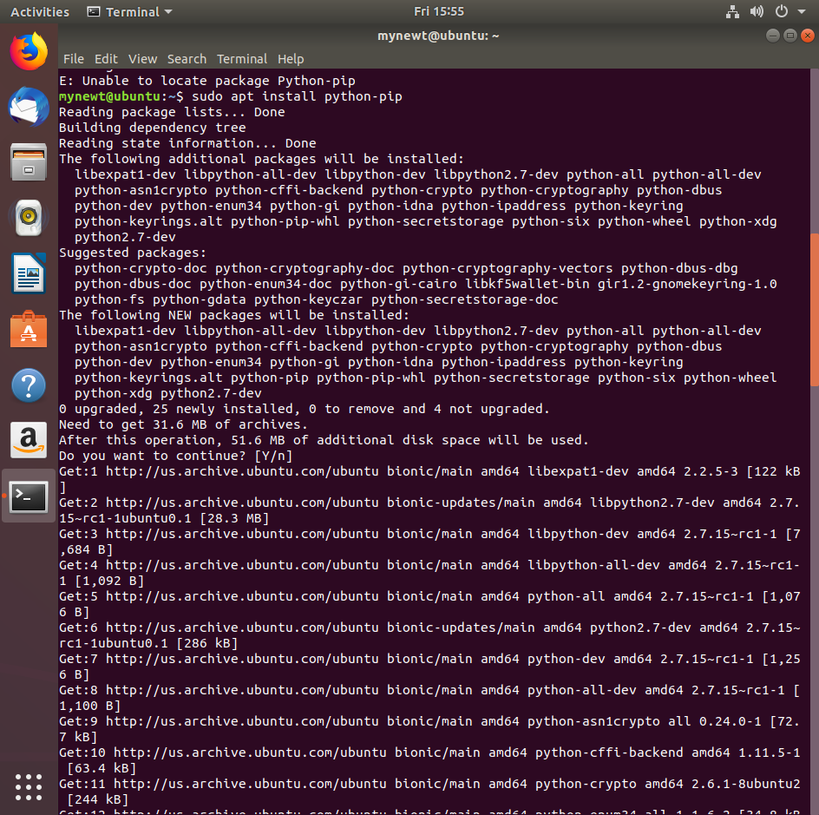

Ilustration 20 Pip installation (1/3)



Ilustration 21 Pip installation (2/3)

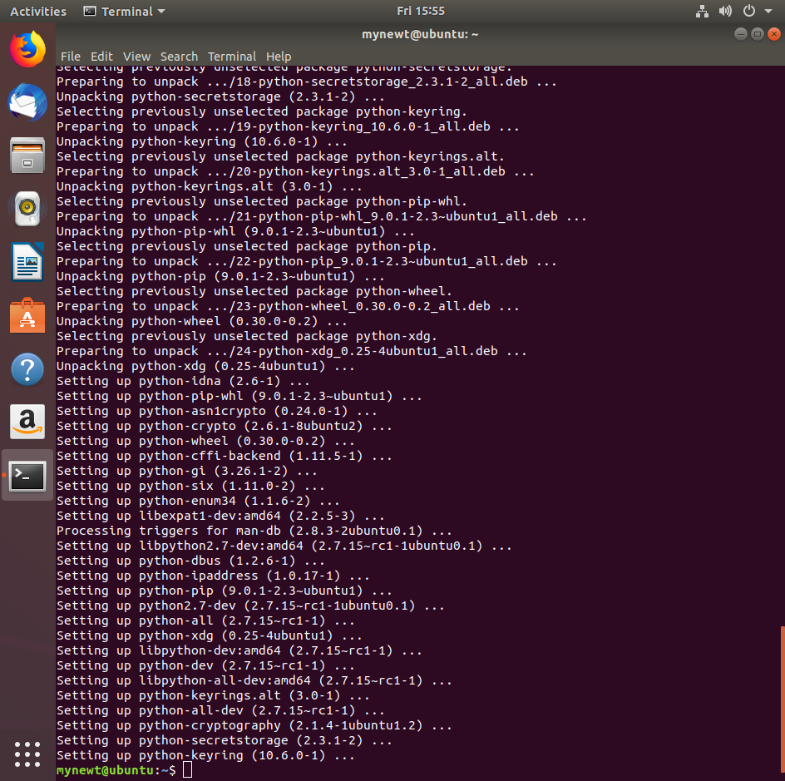

Ilustration 22 Pip installation (3/3)

$ pip install pyocd

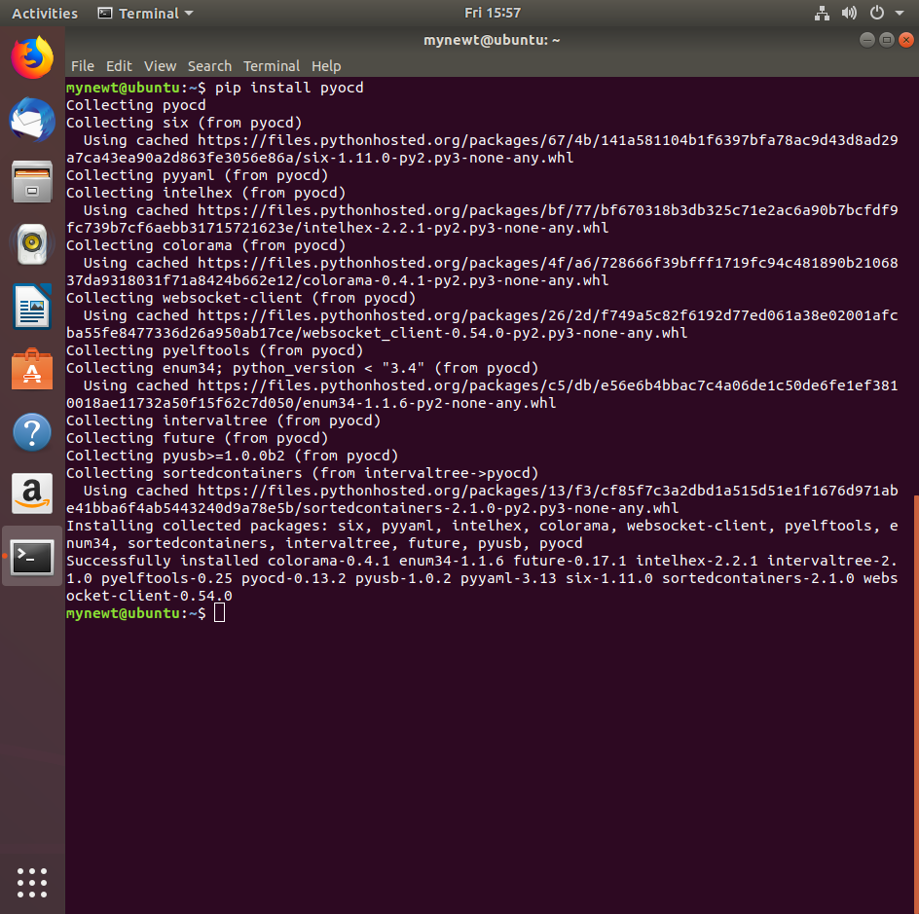

Ilustration 23 PyOCD installation

1. Install ARM Toolchain

$ sudo apt-get remove binutils-arm-none-eabi gcc-arm-none-eabi

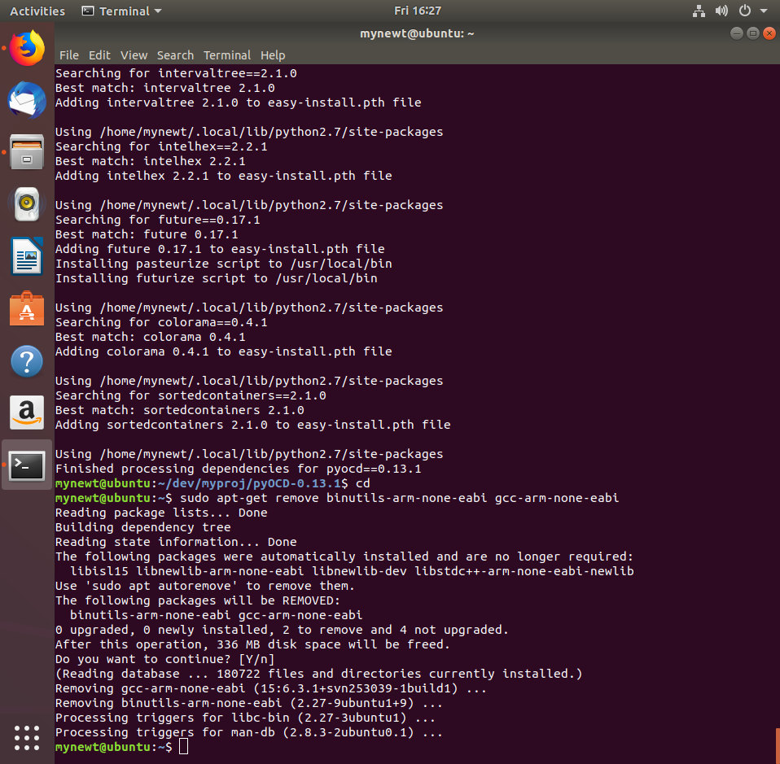

Ilustration 24 Binutils-arm and gcc-arm removal

$ sudo add-apt-repository ppa:team-gcc-arm-embedded/ppa

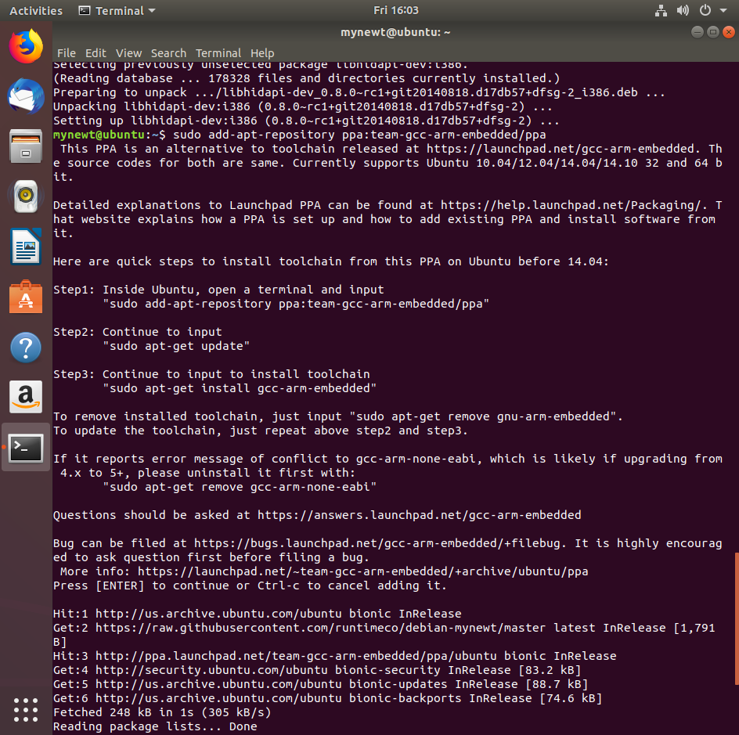

Ilustration 25 Gcc-arm repository addition

$ sudo apt-get update

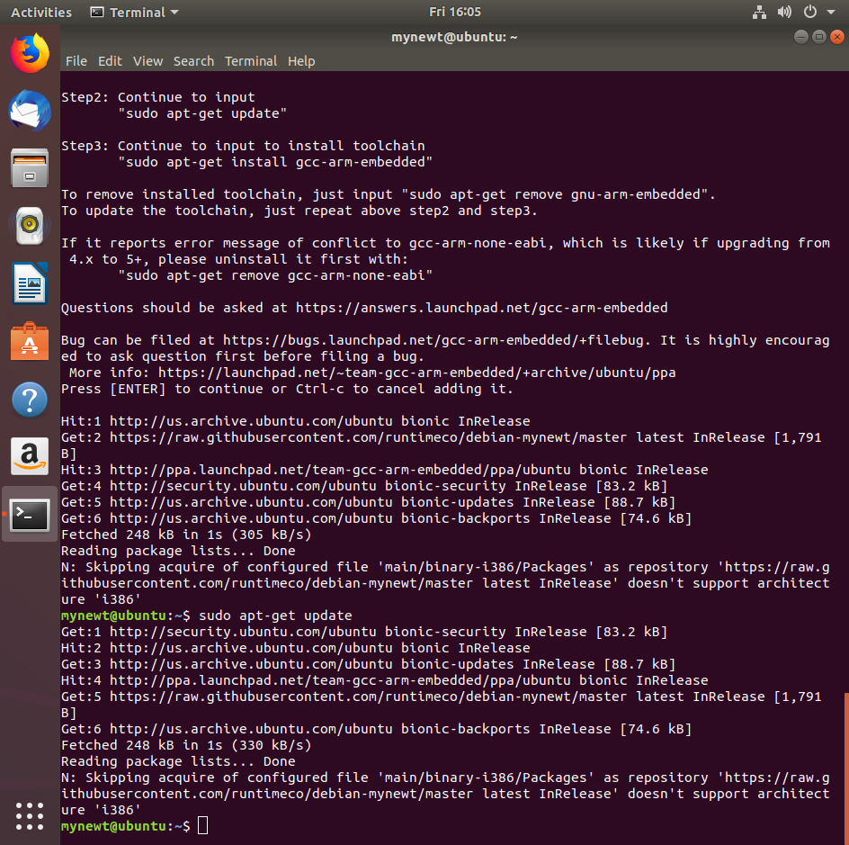

Ilustration 26 Packages update

$ sudo apt-get install gcc-arm-none-eabi

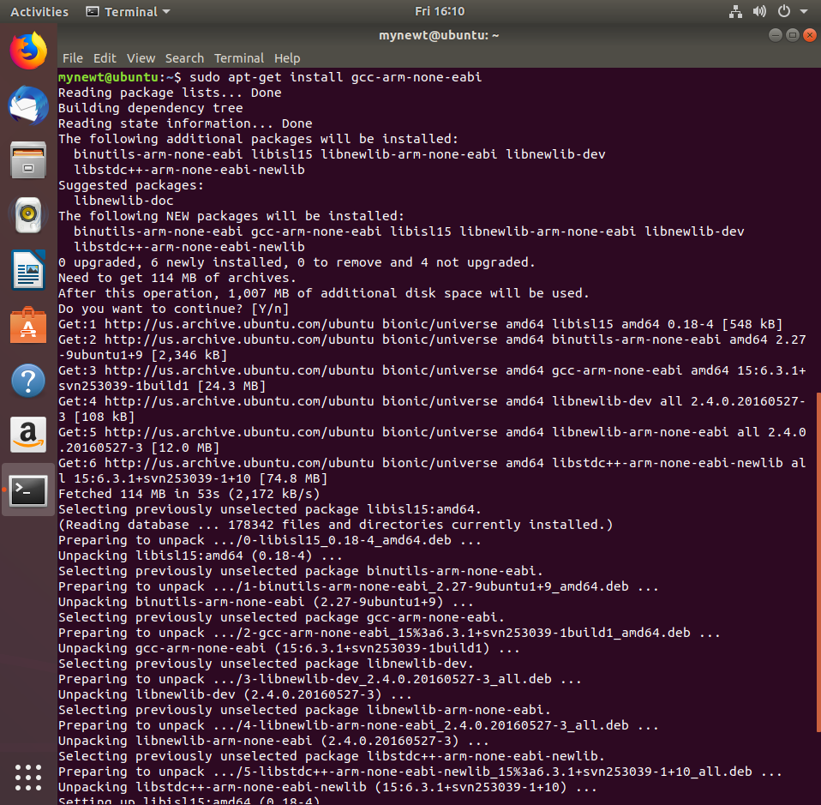

Ilustration 27 Gcc-arm installation (1/2)

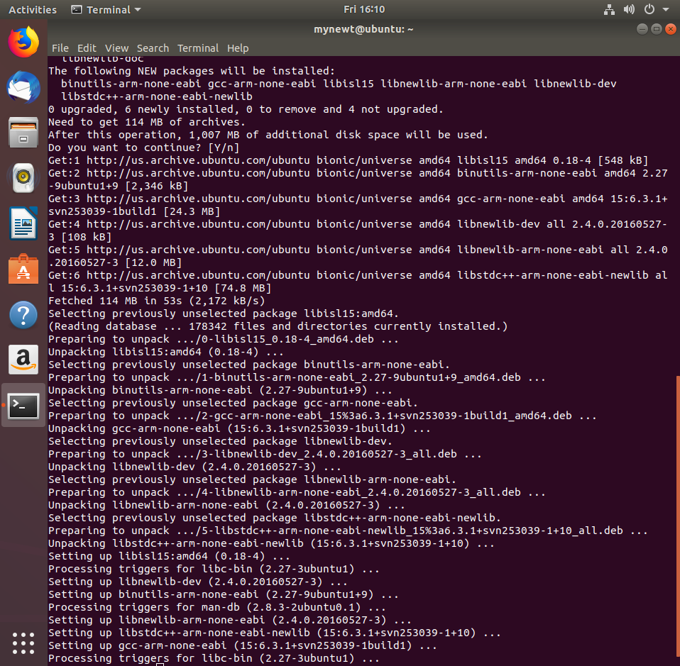

Ilustration 28 Gcc-arm installation (2/2)

1. Install the OpecOCD Debugger
   * Download binary tarball (<https://github.com/runtimeco/openocd-binaries/raw/master/openocd-bin-0.10.0-Linux.tgz>)

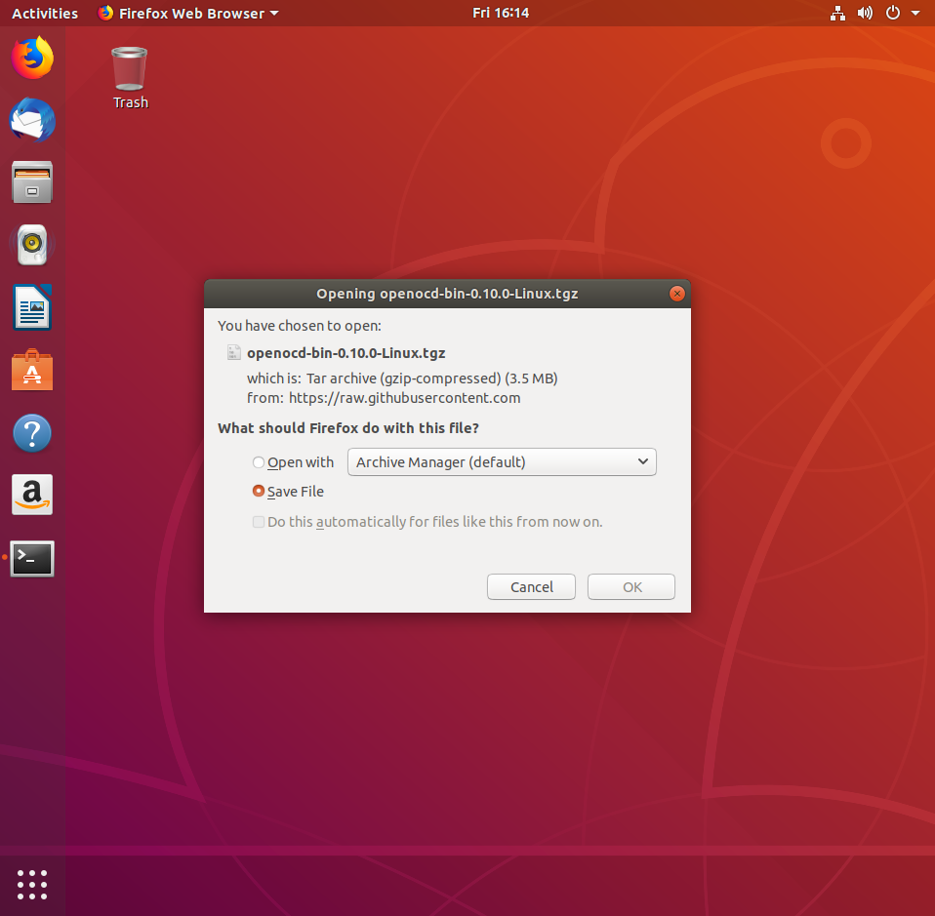

Ilustration 29 OpenOCD download

* + Change to the root directory

$ cd /

* + Untar the tarball and install it into /usr/local/bin (change ~/Downloads with your downloads directory)

$ sudo tar -xpf ~/Downloads/openocd-bin-0.10.0-Linux.tgz

* + Check everything was installed correctly

$ which openocd

$ openocd –v

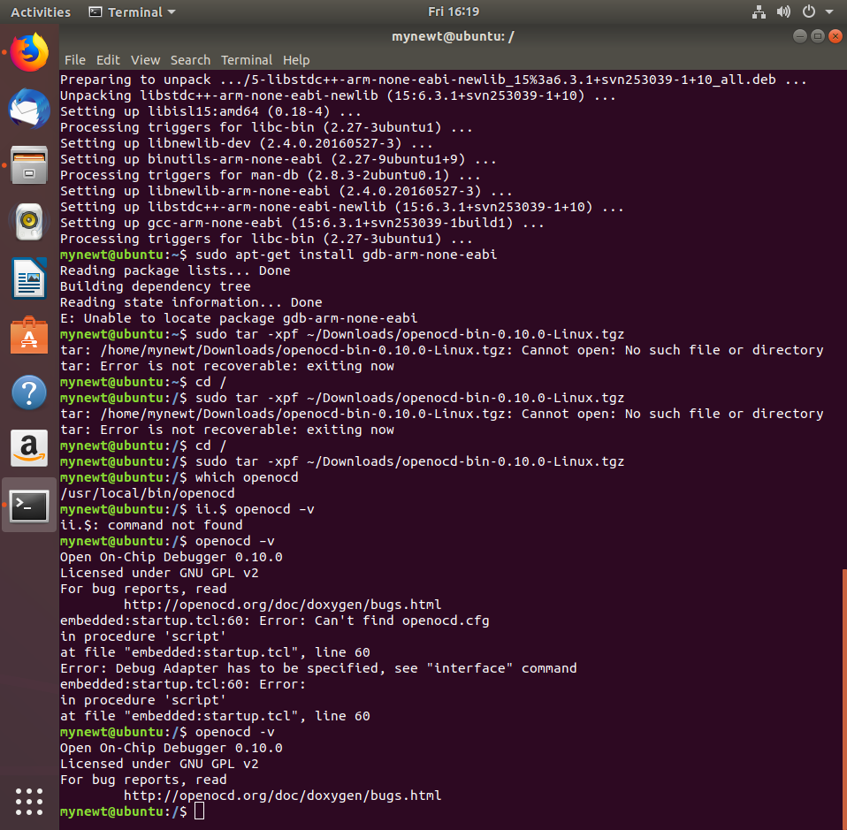

Ilustration 30 Unpackaging OpenOCD



Ilustration 31 OpenOCD version verification

* + In case of any errors, run the following command to install the shared libraries:

$ sudo apt-get install libhidapi-dev:i386

1. Create your first project from your *dev* directory.

$ mkdir ~/dev

$ cd ~/dev

$ newt new myproj

$ cd myproj

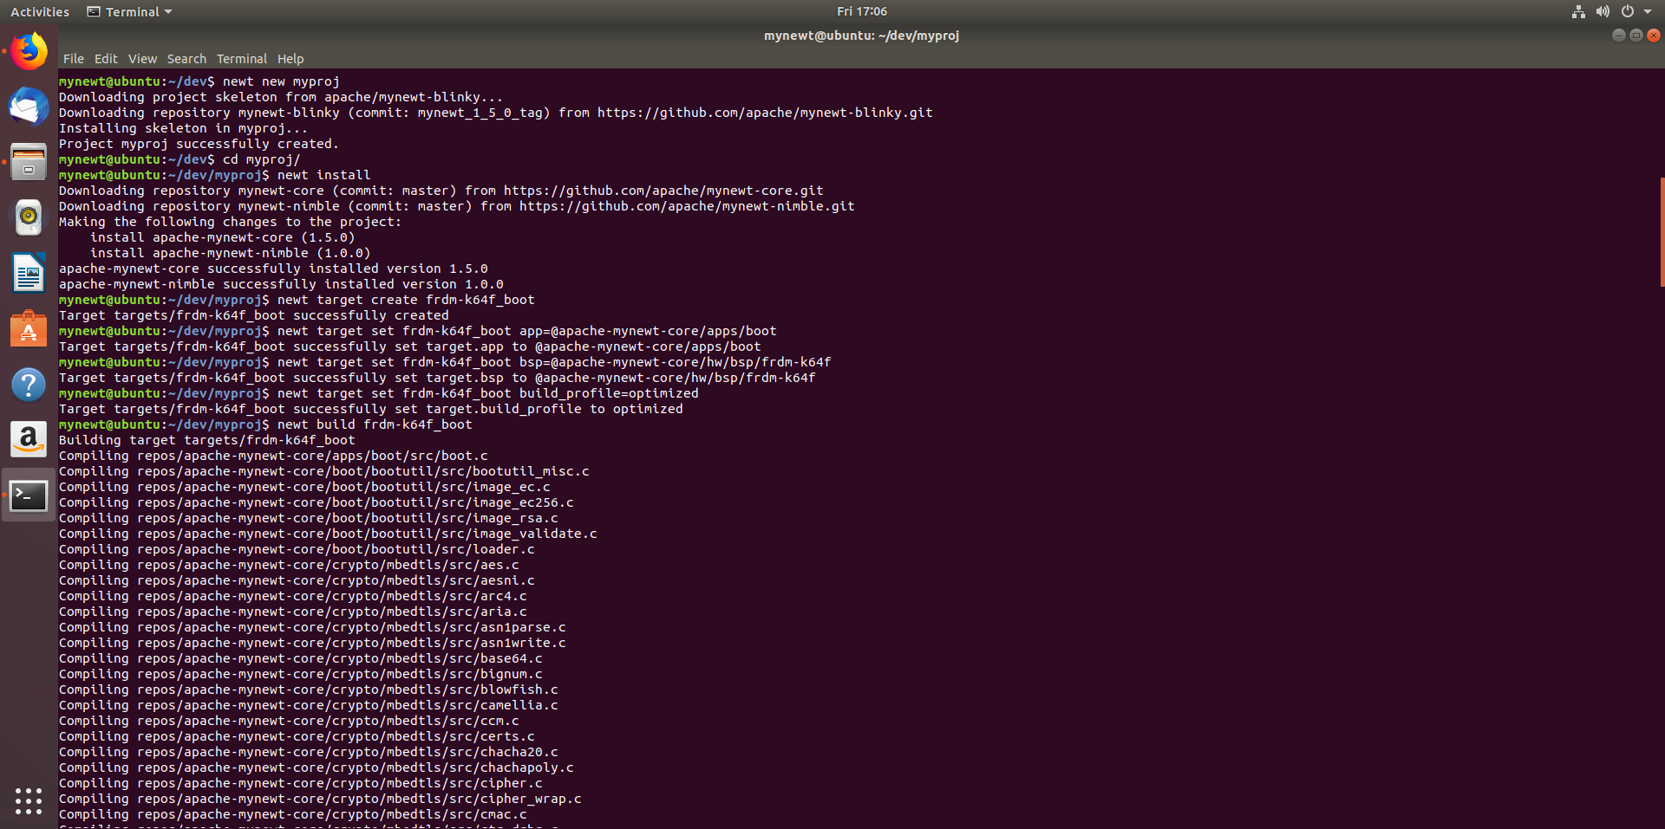

Ilustration 32 Newt new project creation

1. Download Python API from <https://github.com/mbedmicro/pyOCD/releases/tag/v0.13.1>
   * Download *Source code (tar.gz).*
   * Untar the tarball and install it into /dev/myproj (change ~/Downloads with your downloads directory)

$ sudo tar -xpf ~/Downloads/pyOCD-0.13.1.tar.gz

$ cd pyOCD-0.13.1

$ sudo python2 setup.py install

$ cd ..

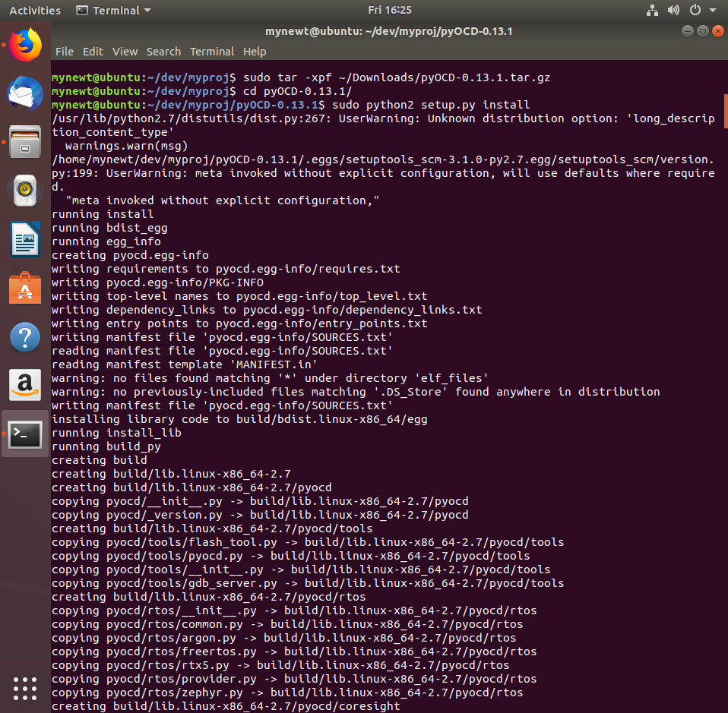

Ilustration 33 PyOCD installation (1/2)

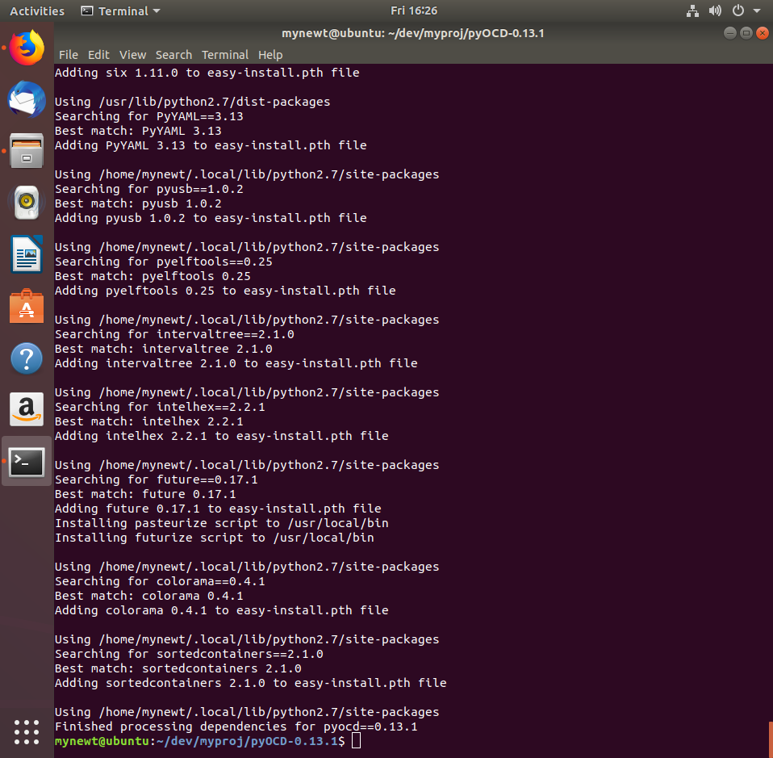

Ilustration 34 PyOCD installation (2/2)

1. Fetch the source repository and dependencies

$ newt install –v

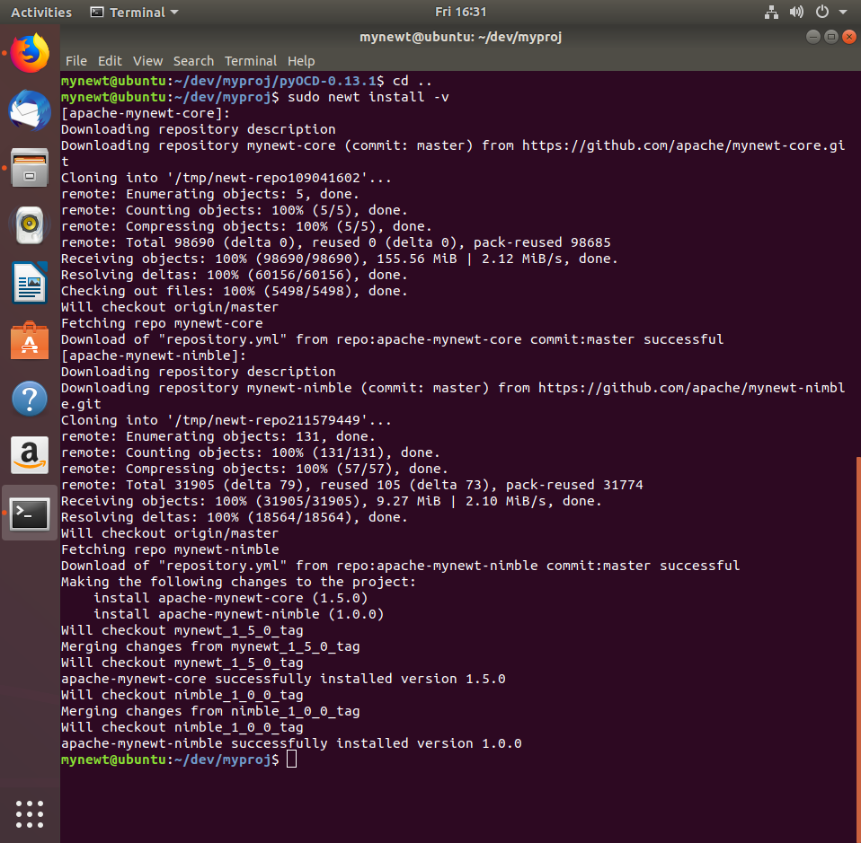

Ilustration 35 Mynewt-core.git cloning

1. Create and load a boot target onto the board
   * Create the boot target:

$ newt target create frdm-k64f_boot

$ newt target set frdm-k64f_boot app=@apache-mynewt-core/apps/boot

$ newt target set frdm-k64f_boot bsp=@apache-mynewt-core/hw/bsp/frdm-k64f

$ newt target set frdm-k64f_boot build_profile=optimized

* + Built the target

$ newt build frdm-k64f_boot



Ilustration 36 Boot targets creation (1/2)

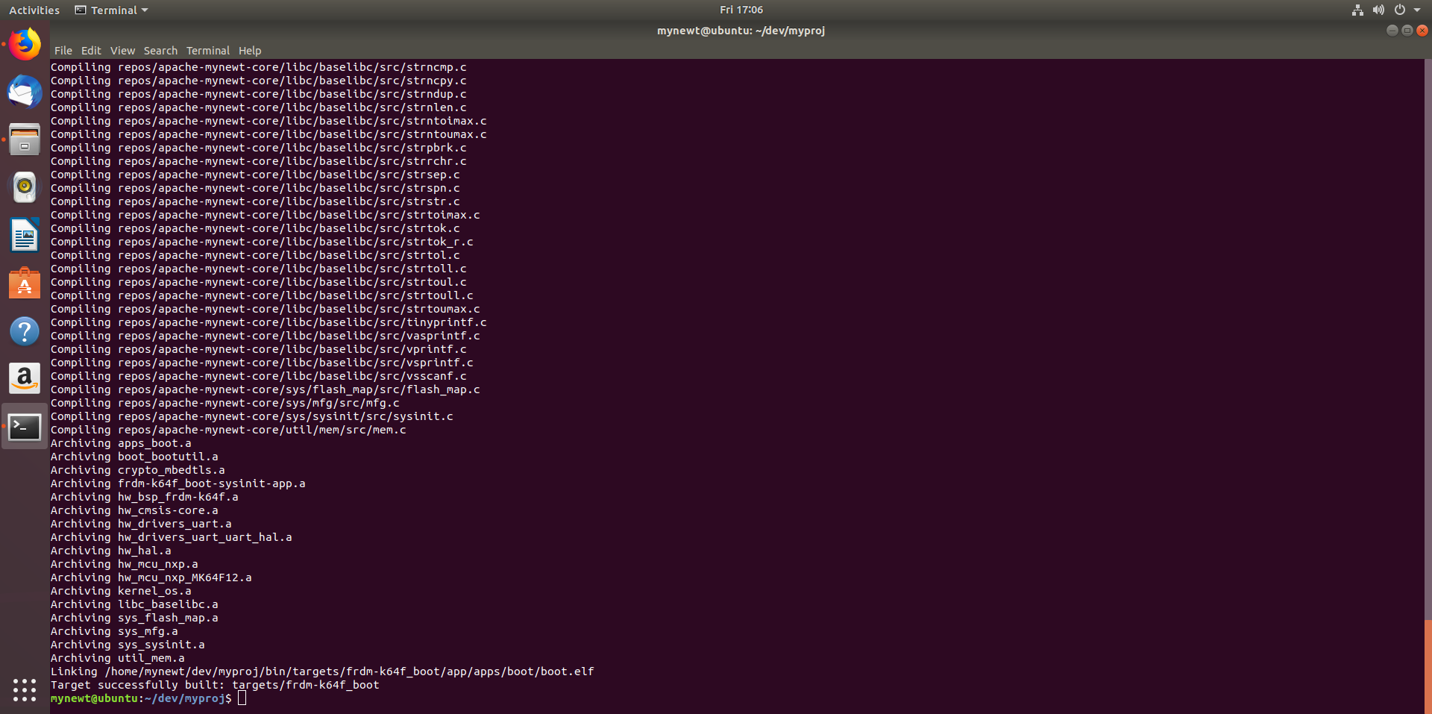

Ilustration 37 Boot targets creation (2/2)

* + Connect the board
  + Load the bootloader binary onto the board

$ newt load frdm-k64f_boot

* + 1. Alternatively, load the boot binary onto the board using SEGGER (download instructions at the end of the document).
       - 1. Enter the directory where *boot.elf.bin* is located

$ Cd dev/myproj/bin/targets/frdm-k64f_boot/app/apps/boot

* + - * 1. Enter the SEGGER CLI interface

$ JLinkExe -device MK64FN1M0VLL12 -speed 1000 -if SWD

* + - * 1. Connect to the board

>connect

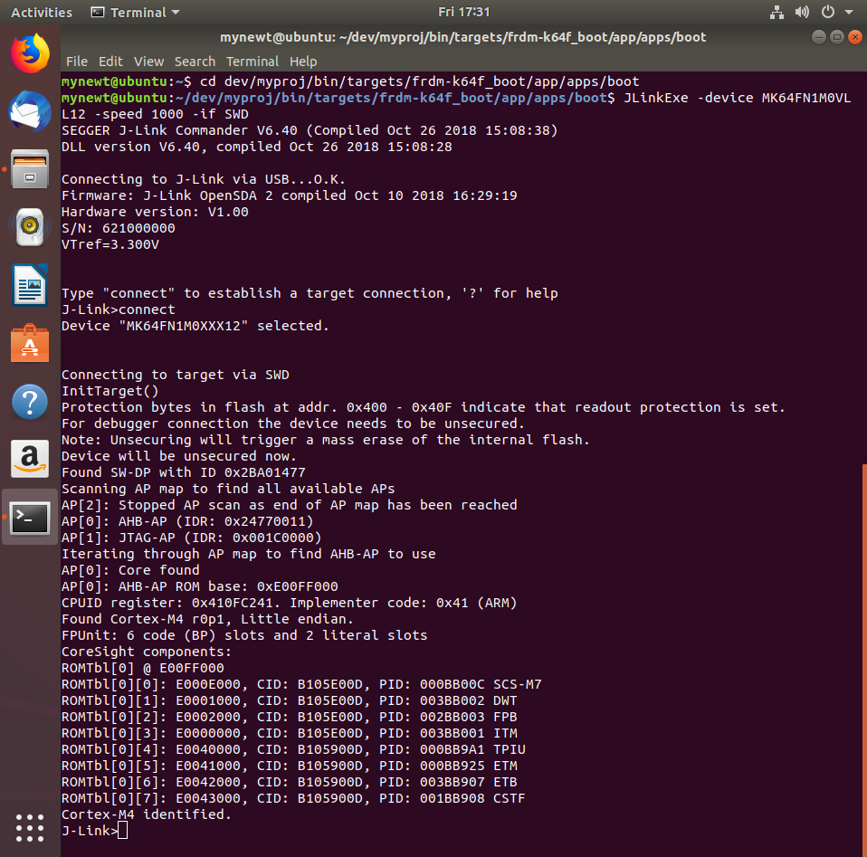

Ilustration 38 JlinkExe boot flashing

* + - * 1. Erase the flash

>erase

* + - * 1. Load the bootloader binary

>loadbin boot.elf.bin, 0x0

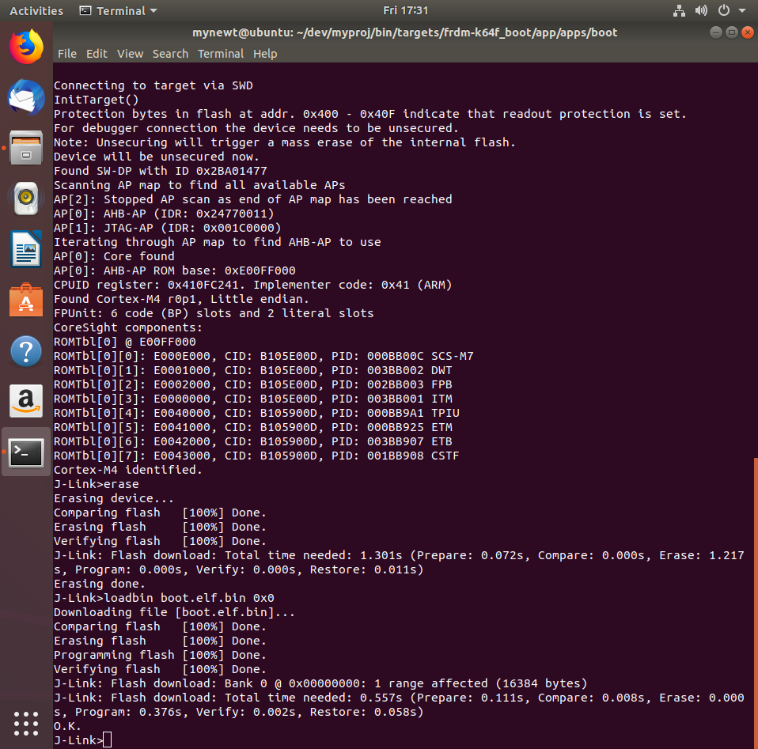

Ilustration 39 JlinkExe flash erase and boot.elf.bin load

* + - * 1. Exit SEGGER CLI interface

>exit

1. Test the board by blinking a LED via Project Blinky
   * Create the blinky target

$ newt target create frdm-k64f_blinky

$ newt target set frdm-k64f_blinky app=apps/blinky

$ newt target set frdm-k64f_blinky bsp=@apache-mynewt-core/hw/bsp/frdm-k64f

$ newt target set frdm-k64f_blinky build_profile=debug

* + Built the target

$ newt build frdm-k64f_blinky

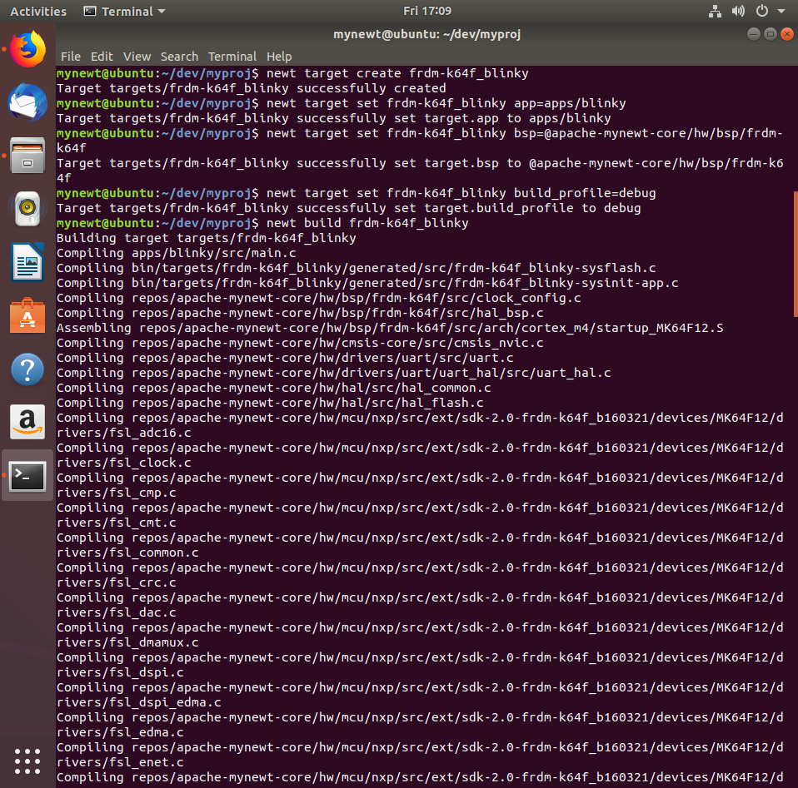

Ilustration 40 Blinky targets creation (1/2)

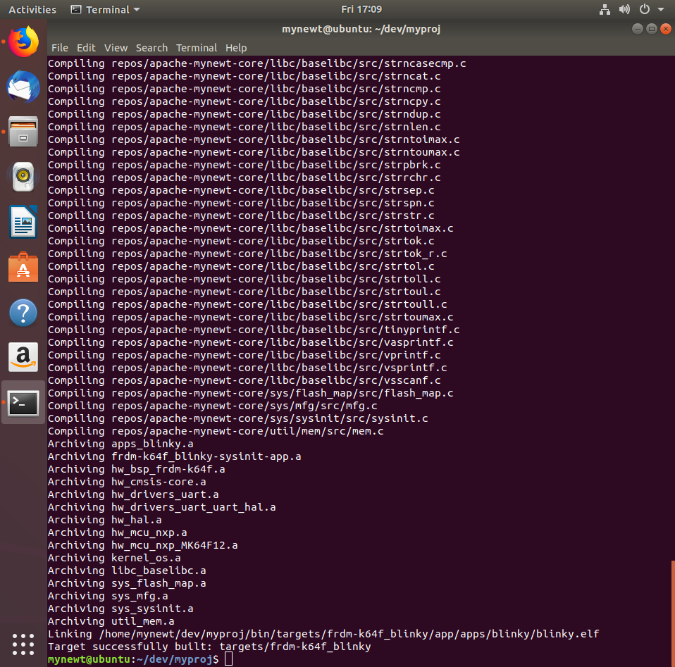

Ilustration 41 Blinky targets creation (2/2)

* + Create the Blinky application image

$ newt create-image frdm-k64f_blinky 1.0.0

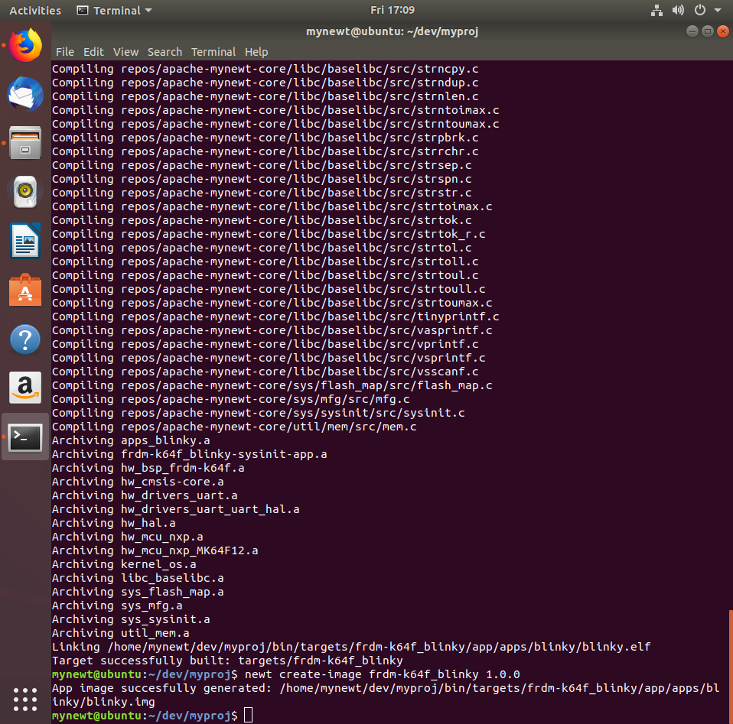

Ilustration 42 Blinky image creation

* + Connect the board
  + Load the Blinky binary onto the board

$ newt load frdm-k64f_blinky

Alternatively, load the Blinky binary onto the board using SEGGER (download instructions at the end of the document).

* + - * Enter the directory where *blinky.elf.bin* is located

$ cd dev/myproj/bin/targets/frdm-k64f_blinky/app/apps/blinky

* + - * Enter the SEGGER CLI interface

$ JLinkExe -device MK64FN1M0VLL12 -speed 1000 -if SWD

* + - * Connect to the board

>connect

* + - * Load the Blinky binary

>loadbin blinky.elf.bin, 0x20000

* + - * 1. 0x20000 is the flash address where applications must be written to, according to <https://test-microplatform-docs.readthedocs.io/en/stable/fota-demo/iot-device/nxp_k64f.html?fbclid=IwAR1DLbVCDTi_mcFcSS1uXajFjdjqHmkUgfMOjU5IImgtPqt3tST8IwPnpOo>
      * Run the application

>g

* + - * If the LED doesn’t blink, you can try resetting the board

>r

* + - * **Note:** use >h to halt the application if needed.
  + The board’s LED should blink!

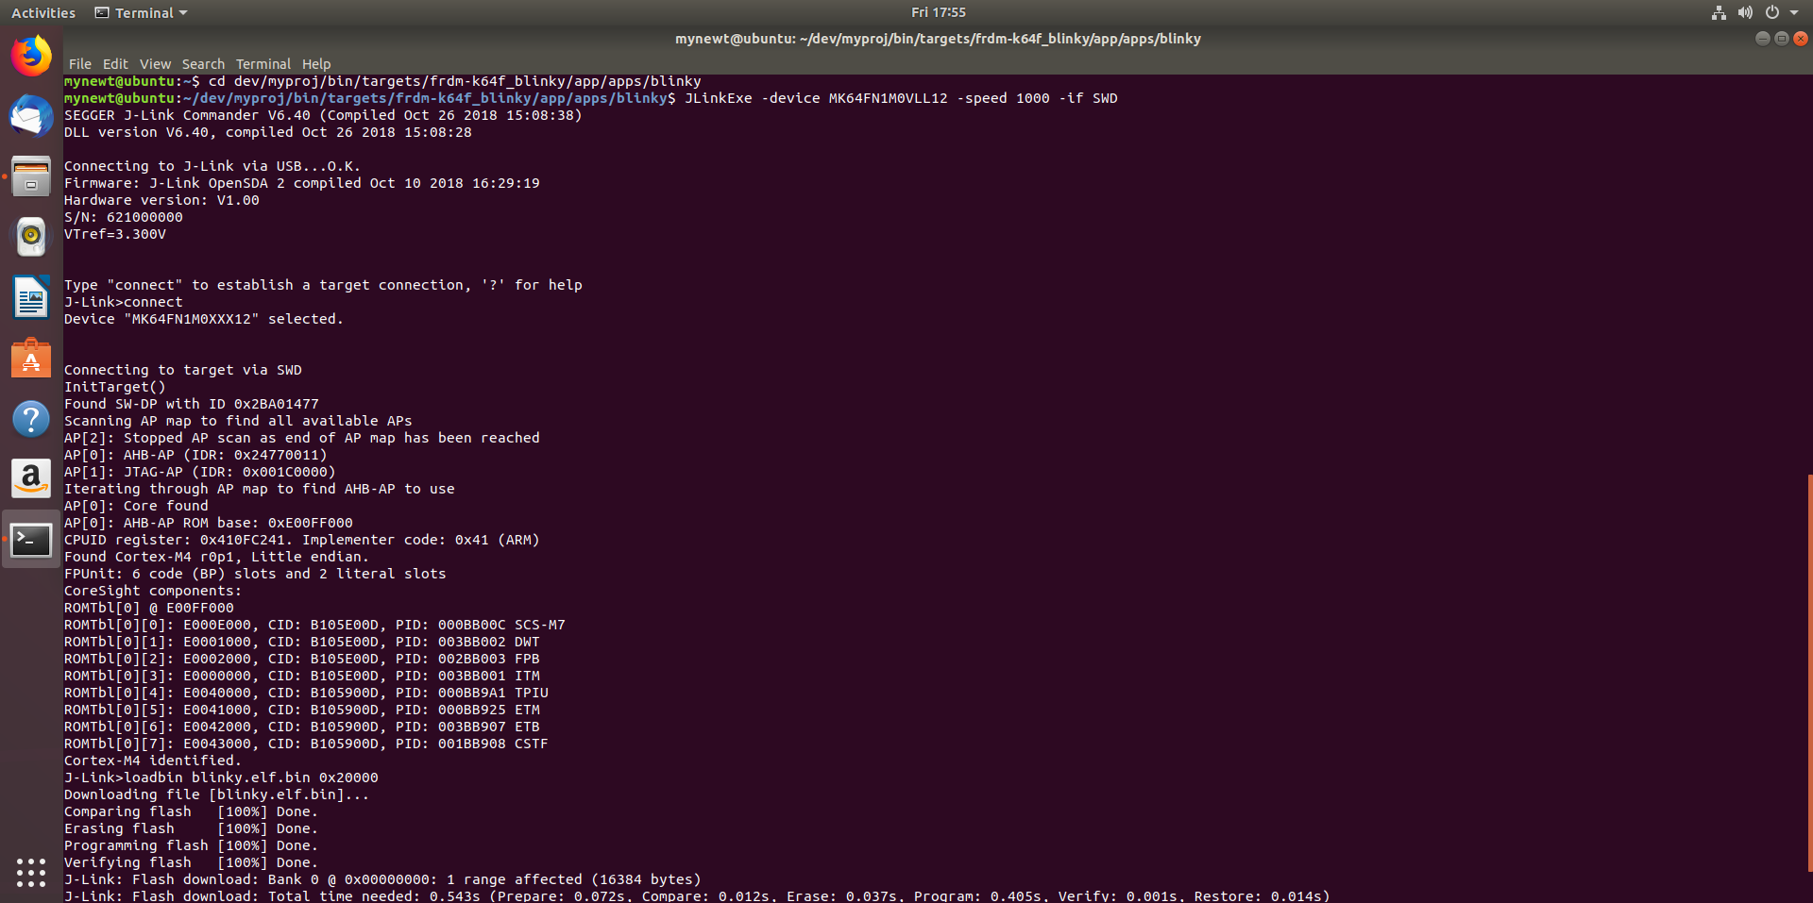

Ilustration 43 JlinkExe blinky.elf.bin load

**Compile and run a client-server application:**

1. Copy the iptest directory onto the apps directory in myproj (where the blinky project is).
2. You can find a resumed and commented version of main.c (the file inside src directory) in the following git: <https://github.com/ArnoldoZerecero/Practicas-Interfaces-y-Perifericos/blob/master/Mynewt%20iptest/main.c>. Feel free to use it if desired.
3. Create the iptest target

$ newt target create frdm-k64f_ iptest

$ newt target set frdm-k64f_iptest app=apps/iptest

$ newt target set frdm-k64f_iptest bsp=@apache-mynewt-core/hw/bsp/frdm-k64f

$ newt target set frdm-k64f_iptest build_profile=debug

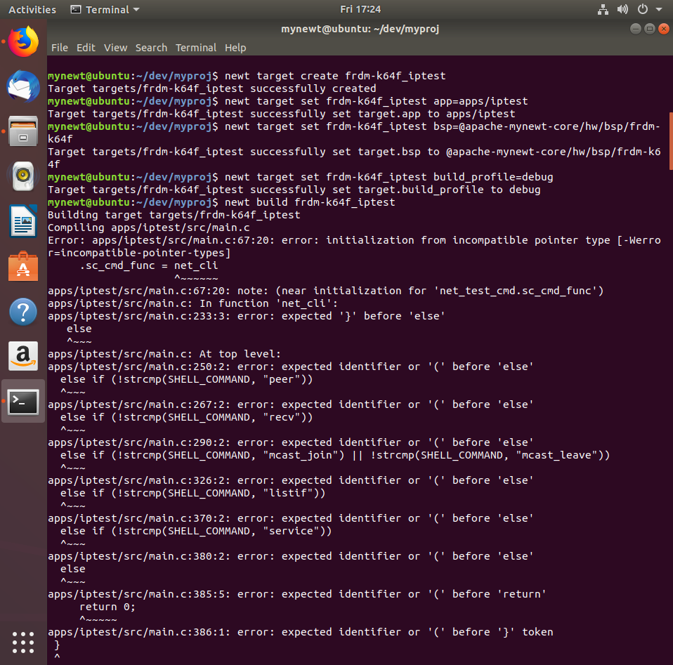

Ilustration 44 Iptest targets creation

1. Built the target

$ newt build frdm-k64f_iptest

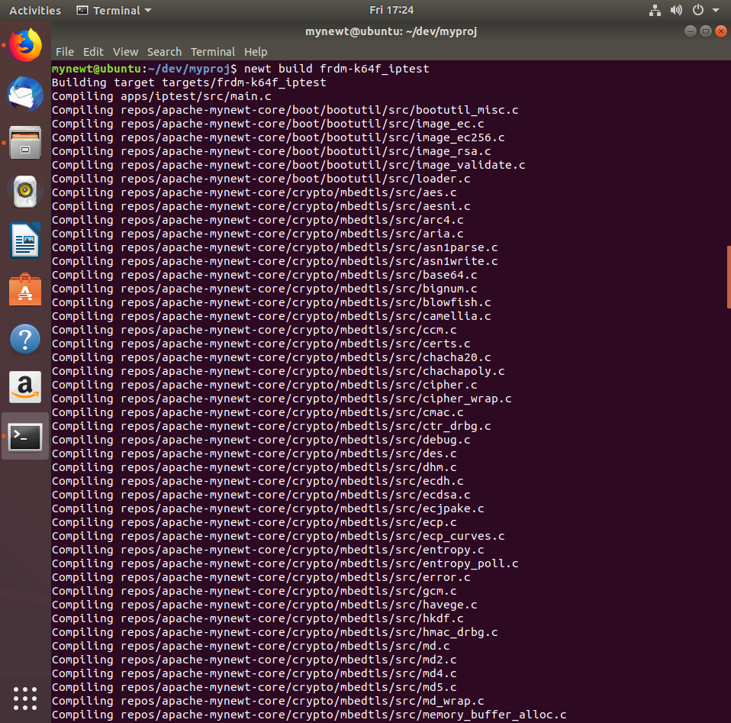

Ilustration 45 Iptest compilation (1/2)

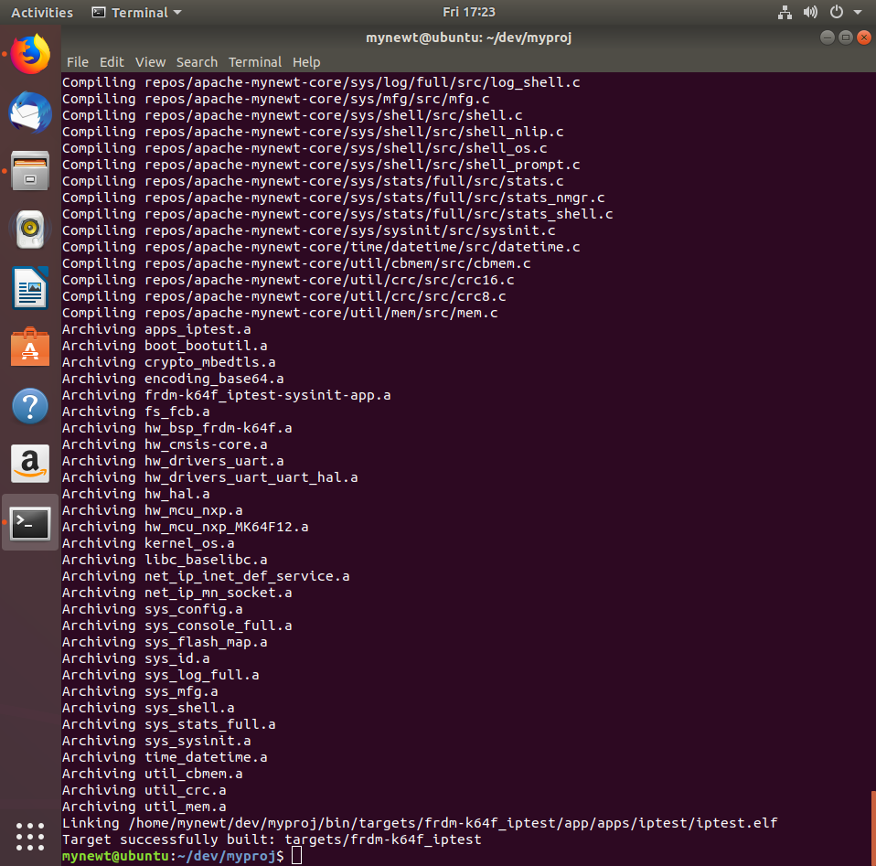

Ilustration 46 Iptest compilation (2/2)

1. Create the iptest application image

$ newt create-image frdm-k64f_iptest 1.0.0

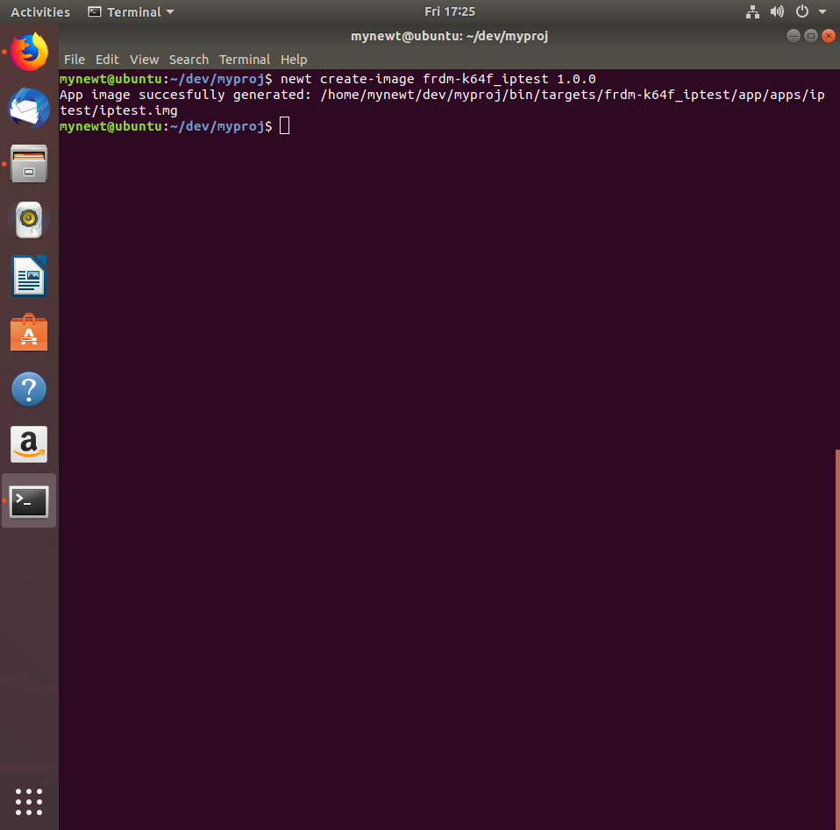

Ilustration 47 Iptest image creation

1. Connect the board
2. Load the iptest binary onto the board

newt load frdm-k64f_iptest

* + Alternatively, load the iptest binary onto the board using SEGGER (download instructions at the end of the document).
    1. Enter the directory where *iptest.elf.bin* is located

$ cd dev/myproj/bin/targets/frdm-k64f_blinky/app/apps/iptest

* + 1. Enter the SEGGER CLI interface

$ JLinkExe -device MK64FN1M0VLL12 -speed 1000 -if SWD

* + 1. Connect to the board

>connect

* + 1. Load the iptest binary

>loadbin iptest.elf.bin, 0x20000

* + - * 0x20000 is the flash address where applications must be written to, according to <https://test-microplatform-docs.readthedocs.io/en/stable/fota-demo/iot-device/nxp_k64f.html?fbclid=IwAR1DLbVCDTi_mcFcSS1uXajFjdjqHmkUgfMOjU5IImgtPqt3tST8IwPnpOo>
    1. Run the application

>g

* + 1. **Note:** use >h to halt the application if needed.

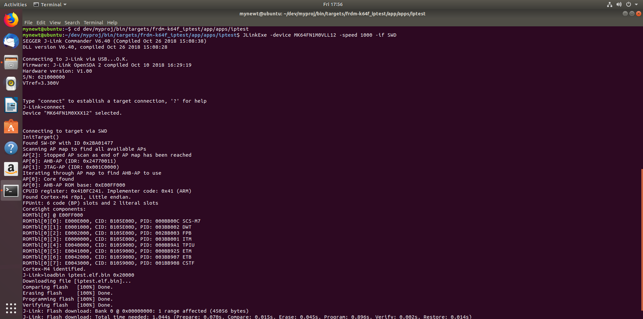

Ilustration 48 JlinkExe iptest.elf.bin load

**Reprogramming the board’s OpenSDA to use SEGGER JLink V2 Firmware:**

1. Install *J-Link Software and Documentation Pack* from <https://www.segger.com/downloads/jlink/>
   * Choose the *J-Link Software and Documentation pack for Linux, DEB installer, 64-bit* option.
   * Choose the open with “Software Install” option.

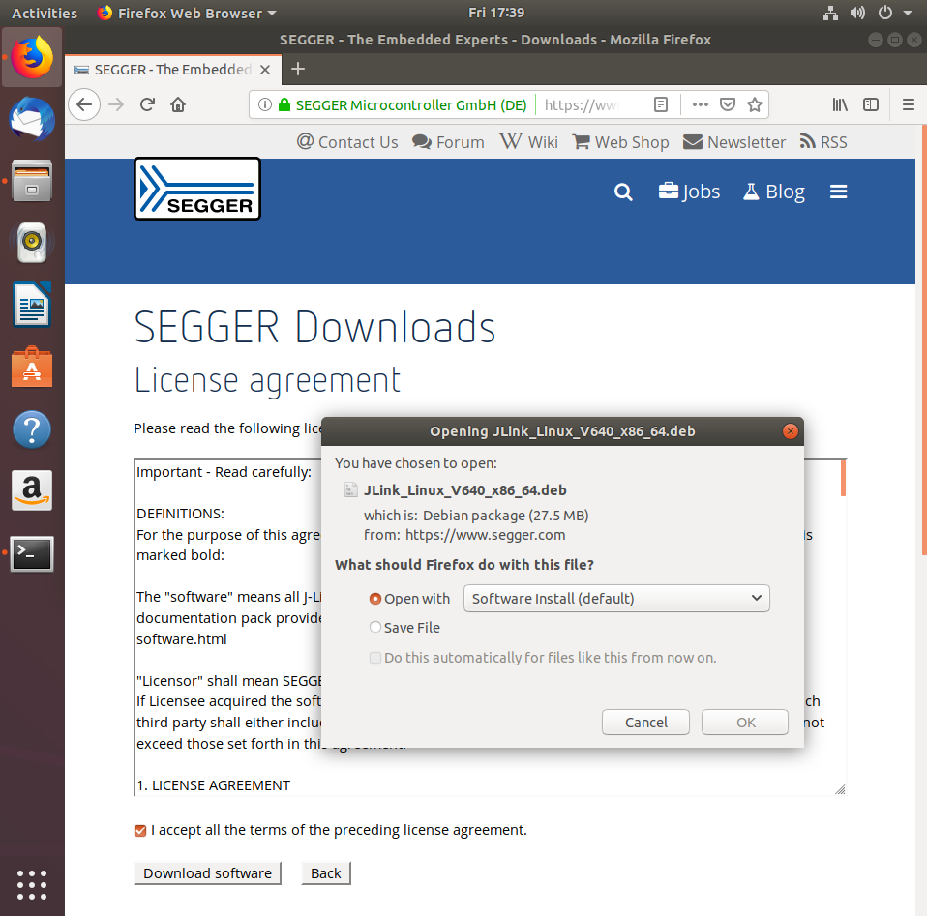

Ilustration 49 Segger Jlink downloading

* + The Ubuntu Software store will be opened.
  + Click “Install”.

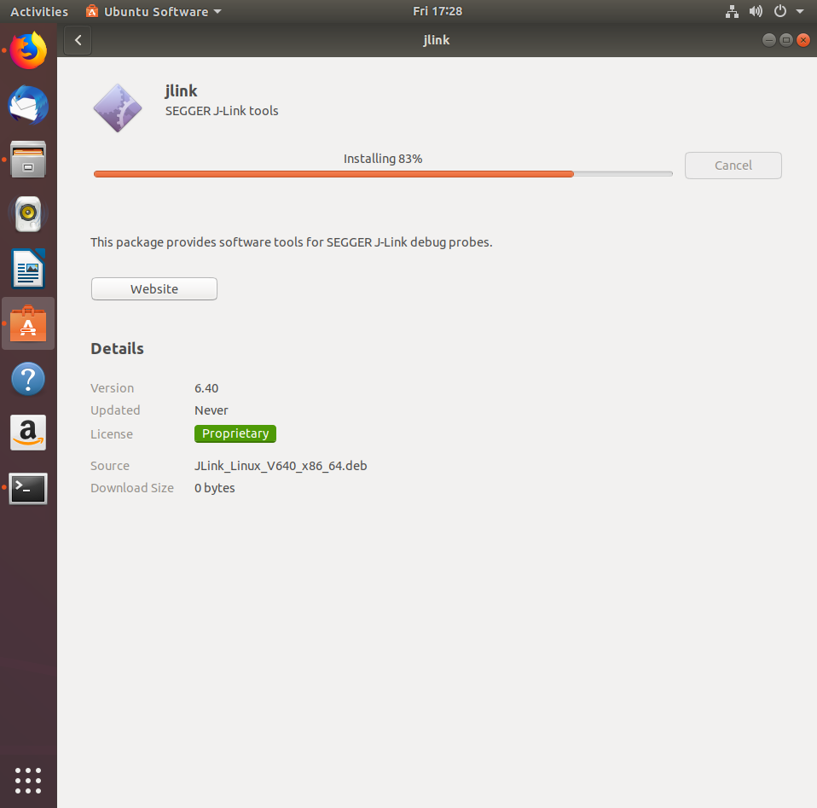

Ilustration 50 Jlink installation

1. Download the binary for the additional OpenSDA Application (SEGGER JLink 2) from <https://www.nxp.com/support/developer-resources/run-time-software/kinetis-developer-resources/ides-for-kinetis-mcus/opensda-serial-and-debug-adapter:OPENSDA?&tid=vanOpenSDA#FRDM-K64F>
   * Follow the link to download Segger JLink V2 for the FRDM-K64F (Download Binary)
   * Reprogram your OpenSDA adapter (as indicated in the previous link from NXP)
     1. Search for OpenSDA Board Specific Firmwares in the *Segger JLink drivers* link
     2. Download the one for the FRDM-K64F board
     3. **Note:** In case of wanting to use *newt load* again instead of SEGGER, you must reprogram the OpenSDA adapter again to use DAPLink. Instructions are found in the NXP link above.

**References and other helpful links:**

**NXP FRDM-K64F (Zephyr)**

[**https://docs.zephyrproject.org/1.11.0/boards/arm/frdm_k64f/doc/frdm_k64f.html**](https://docs.zephyrproject.org/1.11.0/boards/arm/frdm_k64f/doc/frdm_k64f.html)

**NXP OpenSDA (Zephyr)**

[**https://docs.zephyrproject.org/1.11.0/tools/opensda.html#nxp-opensda-pyocd**](https://docs.zephyrproject.org/1.11.0/tools/opensda.html#nxp-opensda-pyocd)

**How to build an app with Mynewt**

[**https://davidgs.com/2017/building-an-app-with-apache-mynewt/**](https://davidgs.com/2017/building-an-app-with-apache-mynewt/)

**Mynewt documentation (Go and Newtmgr installation)**

[**https://wiki.makerdiary.com/nrf52832-mdk/mynewt/**](https://wiki.makerdiary.com/nrf52832-mdk/mynewt/)

[**https://mynewt.apache.org/latest/misc/go_env.html#installing-go-and-git-on-linux**](https://mynewt.apache.org/latest/misc/go_env.html#installing-go-and-git-on-linux)

**Developing Mynewt Applications with Visual Studio Code**

[**https://mynewt.apache.org/latest/misc/ide.html**](https://mynewt.apache.org/latest/misc/ide.html)

**OpenOCD**

[**http://openocd.org/doc/html/Debug-Adapter-Configuration.html**](http://openocd.org/doc/html/Debug-Adapter-Configuration.html)

**Msys install**

[**https://github.com/msys2/msys2/wiki/MSYS2-installation**](https://github.com/msys2/msys2/wiki/MSYS2-installation)